THE INFLUENCE OF KAHOOT IN IMPROVING STUDENTS’
VOCABULARY MASTERY FOR THE FIFTH
GRADE AT SDN 1 TATURA



THESIS

Submitted as a Partial Fulfillment of the Requirements to Obtain a Degree of Sarjana
Pendidikan (S. Pd) at English Tadris Study Program Faculty of Tarbiyah and
Teacher Training at State Islamic University Datokarama Palu

By

NANDA AMALIAH
NIM: 21.1.16.0008

FACULTY OF TARBIYAH AND TEACHER TRAINING
STATE ISLAMIC UNIVERSITY DATOKARAMA PALU
2025
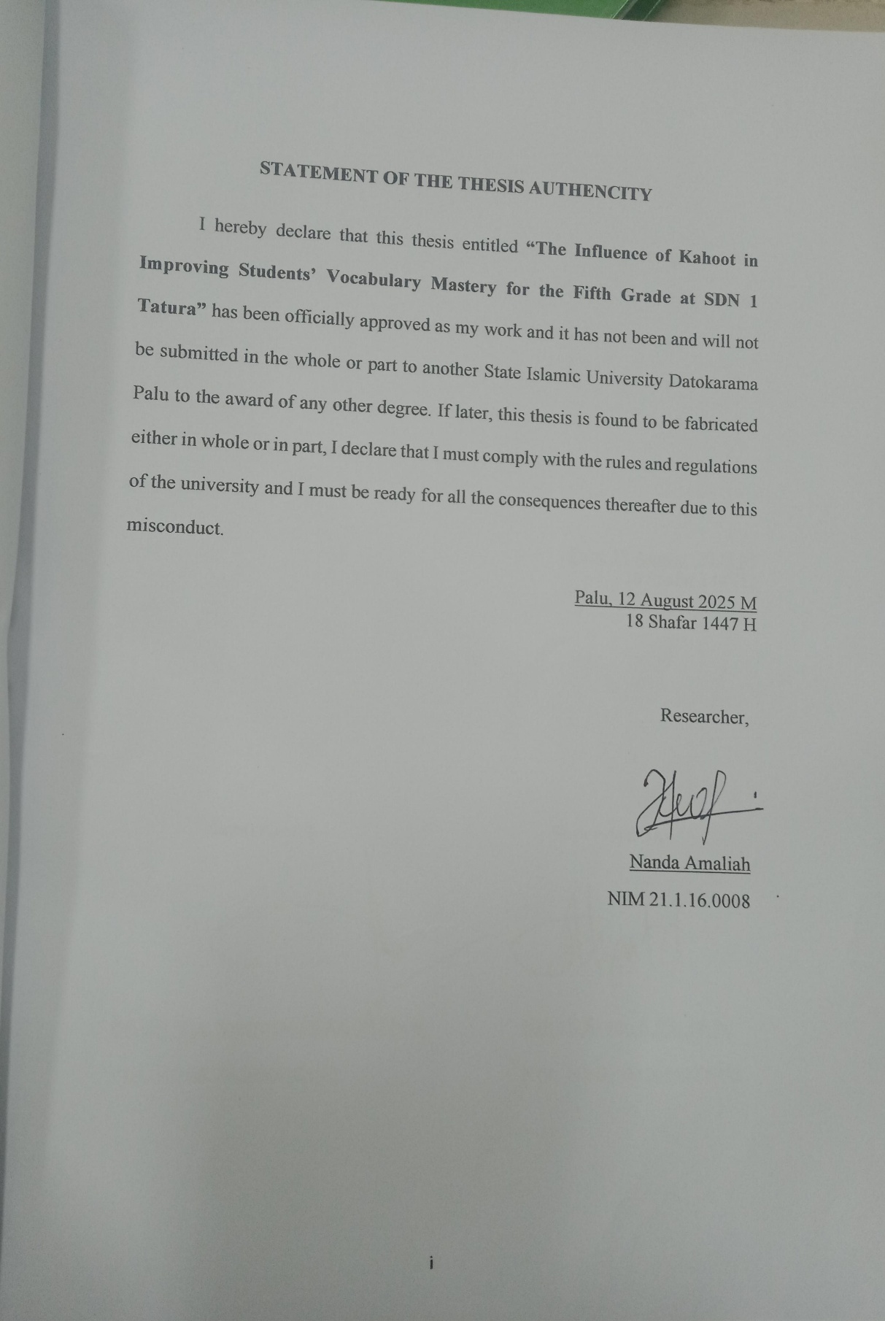

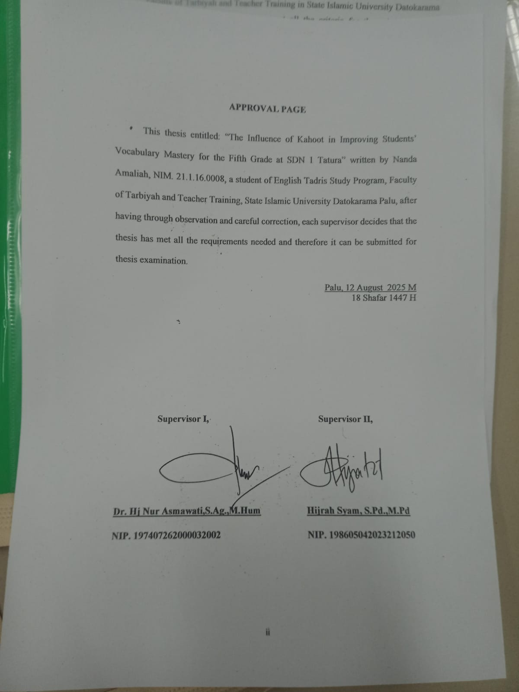

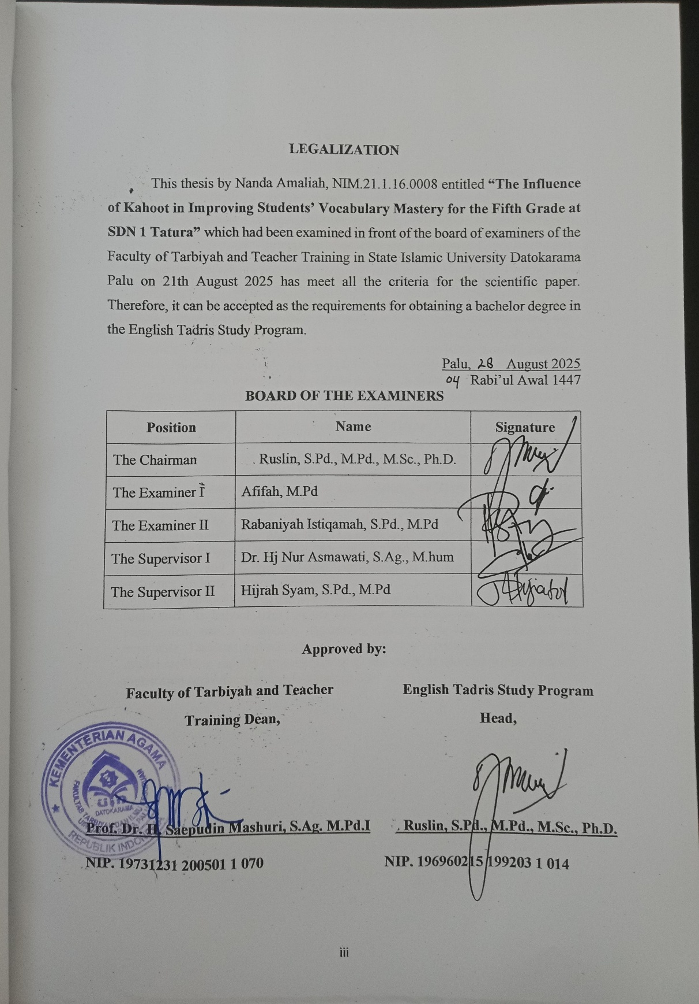

ABSTRACT
Name :  NIM :  Thesis Title : | Nanda Amaliah  21.1.16.0008  THE INFLUENCE OF KAHOOT IN IMPROVING STUDENTS’ VOCABULARY MASTERY FOR THE FIFTH GRADE AT SDN 1 TATURA

Vocabulary mastery is one of the main challenges in English learning for fifth-grade students at SDN 1 Tatura. This condition affects the teaching and learning process, resulting in decreased student interest and motivation in learning English, with some perceiving it as boring and less useful. Considering the importance of English for future communication and academic success, teachers need to adopt engaging learning strategies to foster student interest.
The research question of this research was: " Is there any influence of Kahoot in improving students’ vocabulary mastery for the fifth grade at SDN 1 Tatura?". This research aimed to find out the influence of kahoot improving students’ vocabulary mastery for the fifth grade at SDN 1 Tatura.
This research a quantitative method with a quasi-experimental design was used, involving two classes: the experimental group (26 students) taught by using Kahoot and the control group (25 students) taught with conventional methods. The research instrument was a vocabulary test consisting of 20 multiple-choice items, administered as a pre-test and post-test.
The results showed that the experimental group’s post-test mean score (74.00) was significantly higher than that of the control group (57.69), with a t-test value (12.648) greater than the t-table value (2.060). Based on these findings, H₀ was rejected and Hₐ was accepted, confirming that Kahoot has a significant influence students’ vocabulary mastery.
The implications of this study indicate that integrating interactive learning tools such as kahoot into English language instruction can enhance student engagement, enrich vocabulary acquisition, and make the learning process more enjoyable. Teachers and educational institutions are encouraged to adopt similar digital media to support language learning, especially in contexts where students’ motivation and interest in English remain low.

ACKNOWLEDGEMENT
The researcher would like to express gratitude and thanks to Allah SWT who has given permission, opportunity, time, and blessings to the researcher so that the researcher can complete this thesis entitled “The Influence of Kahoot in Improving Students’ Vocabulary Mastery for the Fifth Grade at SDN 1 Tatura” in accordance with the specified time. The researcher would like to express the gratitude and greetings to the Prophet Muhammad SAW who taught, guided, and led us to live a life that is in accordance with the way it should be.
The researcher realizes that this thesis entitled “The Influence of Kahoot in Improving Students’ Vocabulary Mastery for the Fifth Grade at SDN 1 Tatura” is far from perfect, both in terms of content and writing techniques. Limited knowledge, time, and experience also affect the final result of this research. Nevertheless, the researcher hopes that this simple work can still contribute to readers, especially in understanding the importance of vocabulary for language learners.
In this section, the researcher would like to express her deepest gratitude to all those who have provided support, assistance, and meaningful contributions during the process of writing this work, both directly and indirectly. Without the help of various people, whether in the form of scientific guidance, moral motivation, or spiritual support, the writing of this thesis would certainly not be able to be completed properly. Every form of attention and assistance provided is greatly appreciated by the researcher and is an important part in the preparation of this thesis. In this section, the researcher would like to express a deep appreciation to the following people:
- The researcher’s beloved parents, Ihsan and Fitriah, for their unconditional love, sacrifices, greatest support, patience, and constant prayers. Hopefully, this simple achievement can be a small offering as a form of dedication and love from the researcher to the researcher's beloved father and mother.
- The Rector of State Islamic University Datokarama Palu, Prof. Dr. KH. Lukman S. Thahir, M.Ag, along with all the leadership who have provided support, direction, and policies that greatly helped researcher in various aspects during the process of completing this thesis.
- Prof. Dr. H. Saepudin Mashuri, S.Ag. M. Pd.I. as the Dean of Teacher Training and Education Faculty, State Islamic University Datokarama Palu, who has provided support, facilities, and policies that allow the researcher to carry out this research smoothly.
- H. Ruslin, S.Pd., M.Pd., M.Sc., Ph.D. as the Head of English Tadris Study Program and Hijrah Syam, S.Pd., M.Pd., as the secretary of English Tadris Study Program, who has provided support, motivation, and direction that is very meaningful to the researcher.
- Dr. Hj. Nur Asmawati,S.Ag.,M.Hum as the first supervisor and Hijrah Syam, S.Pd., M.Pd. as the second supervisor in the preparation of this thesis, who corrected and provided input, and encouragement to the researcher until the completion of this thesis.
- All of the lecturesr that have given useful and meaningful knowledge during the study of researcher in the English Tadris Program, UIN Datokarama Palu.
- Dr Sabna S.Pd., M.Pd. who has patiently guided, directed, and provided valuable input during the process of writing this thesis. In the middle of her busy schedule, the researcher is very grateful for the time and attention given sincerely. Her exemplary behavior, work, and guidance have been an inspiration that the researcher will always appreciate. May all her dedication and sincerity be a jariyah charity that continues to flow and is blessed by Allah SWT.
- All of the fifth grade students in SDN 1 Tatura, who have participated in this research.
- The researcher’s beloved classmates in TBI 1 batch 2021, who always give help, support, experience, and motivation in completing this thesis.
- The researcher’s beloved friends especially Rahadatul Aisy, Riski Rosnanda, Rani Risqi Ambarwati, Yulianisa, Moh Sofyan, who always give motivation and support in all situations and conditions while the researcher was completing the research
- Researcher’s thesis groupmates, Dini Ariyani, Sindi Rahmawati whose support, teamwork, and encouragement meant a great deal during this journey.

LIST OF CONTENTS
STATEMENT OF THESIS AUTHENTICITY i
APPROVAL PAGE ii
ABSTRACT iii
ACKNOWLEDGEMENT v
LIST OF CONTENTS viii
LIST OF THE TABLES x
LIST OF THE PICTURES xi
LIST OF THE APPENDICES xii
CHAPTER I INTRODUCTION 1
- Background of the Research 1
- Research Question 5
- Objective of the Research 5
- Significance of the Research 5
- Research Outlines 6
CHAPTER II LITERATURE REVIEW 7
- Previous Research 7
- Theoritical Review 10
- Definition of Vocabulary 10
- Classification of Vocabulary 11
- Vocabulary Teaching Technique 16
- Vocabulary Mastery 18
- The Nature of Kahoot 19
- Benefits of Kahoot 21
- Steps to Acces Kahoot 22
- Advantages and Disadvantages of Kahoot 23
- Objectives of Kahoot 24
- Conceptual Framework 25
- Hypothesis 26
CHAPTER III RESEARCH METHOD 28
- Approach and Design of Research 28
- Population and Sample of the Research 29
- Research Variables 31
- Operational Definition 32
- Research Instrument 33
- Technique of Data Collection 34
- Technique of Data Analysis 35
CHAPTER IV RESULT AND DISCUSSION 40
- Description of the Research Result 40
- Discussion of the Research Result 53

CHAPTER V CONCLUSION AND SUGGESTIONS 56
- Conclusion 56
- Suggestions 57
REFERENCES
APPENDICES
CURRICULUM VITAE

LIST OF TABLES
Table 3.1 The Scheme of Quasi-Experimental Design 29
Table 3.2 The Number of Population 30
Table 3.3 The Number of Samples 31
Table 3.4 Scoring System 37
Table 4.1 Students’ Scores in Experimental Class 41
Table 4.2 Students’ Scores in Control Class 42
Table 4.5 Descriptive Statistics of Students' Grades 47
Table 4.6 Frequency of values in Experimental and Control Class 47
Table 4.7 Test of Normality 51
Table 4.8 Test of Homogeneity 52
Table 4.9 Test of Independent Sample T-Test 53
Table 4.10 Test of Paired Sample T-Test 54

LIST OF THE APPENDICES
Appendix 1 Modul in the Experimental Class
Appendix 2 Pre-Test
Appendix 3 Post-Test
Appendix 4 Validity Test
Appendix 5 T-Table
Appendix 6 Documentation
Appendix 7 features Kahoot
Appendix 8 Surat Izin Penelitian
Appendix 9 Surat Keterangan Selesai Meneliti
Appendix 10 Pengajuan Judul
Appendix 11 Penunjukan Dosen Pembimbing Skripsi
Appendix 12 Undangan Seminar Proposal
Appendix 13 Kartu Seminar Proposal
Appendix 14 Bukti Bimbingan

CHAPTER I

INTRODUCTION

Background
In the context of current global education, it is essential for the younger generation, especially students, to learn and master English as a Foreign Language. English, as one of the foreign languages is an International Language that plays a crucial role in facilitating interaction between various countries. English has also been regarded as the most commonly used international language worldwide.
In line with the growing need for English in this global era, Indonesia’s education system continues to improve to meet modern demands. One of the government’s major efforts is the implementation of the Merdeka Curriculum, which gives more freedom to schools and teachers to design lessons based on students’ needs.
This curriculum focuses on student-centered learning, encourages the development of various skills, and supports the use of digital technology. With this flexibility, teachers can choose teaching methods and tools that are more interesting and better suited to their students' interests and characteristics. In English learning, the Merdeka Curriculum provides great opportunities to use technology as an interactive and fun learning aid.
The introduction of English at the elementary school level is part of the government's effort to improve the quality of human resources who can compete globally. English is no longer seen as just an extra subject, but as an important skill that students need to master.
One of the skills that elementary school students are expected to master is proficiency in language, which is essential for effective communication and interaction. According to Harmer, there are four key language skills that students must develop: listening, reading, speaking, and writing. To effectively master these skills, students need to be equipped with fundamental language elements, including vocabulary. Mastery of vocabulary is a crucial component in achieving overall language proficiency.
In many cases, English is often perceived as a difficult subject for most students, particularly at the elementary school level. A common challenge encountered in the process of learning English in elementary schools is vocabulary acquisition. According to Yusran Pora, Mastery of vocabulary is essential for anyone wishing to understand readings, conversations, or writings in English. Without sufficient vocabulary, it is impossible to achieve the aforementioned language skills. Purwanti states, when introducing or teaching English vocabulary to children, it is preferable to use innovative and varied instructional media. This approach can help capture children's interest and encourage them to engage more effectively in learning English vocabulary.
In this context, teachers are required to be creative and innovative in developing engaging learning media that actively involve students. One effective approach is utilizing technology and educational games. Through games, the learning process becomes more enjoyable, allowing students to learn while playing.
Through games, students can interact, discover new things, and have fun with their classmates. Lewis states that games are very popular among children because they enjoy playing. Using games not only increases students’ motivation but also creates a need to use the language. To be able to use the language well, students need to learn new vocabulary. Today, there are many types of games that teachers use to teach vocabulary.
One technology-based game that is suitable for today’s students is Kahoot, an interactive digital quiz platform that incorporates visual elements, sound, and competition. Ismail & Mohammad state that using Kahoot can increase student engagement in the learning process. Similarly, Licorish found that Kahoot helps to create a more active, enjoyable, and competitive classroom environment, which positively impacts students’ learning outcomes. With Kahoot, students can learn English in an interactive and fun way, which is expected to help improve their vocabulary.
Dolch stated that the list of essential vocabulary for elementary school students consisted of 220 common words and 95 nouns, making a total of nearly 300–500 words. This list was used as an initial target in learning English.
However, Based pre observations in the fifth-grade class at SDN 1 Tatura, From what the researcher found, the students were only able to recognize around 40–60 basic vocabulary words, far below the target that should have been mastered at the elementary school level. In fact, many students were still unable to recall the meaning of words or use them in simple sentences.
Based on the problem, the researcher was interested in conducting research entitled: "The influence of Kahoot in improving students’ vocabulary mastery for the fifth grade at SDN 1 Tatura".

Research Question
Based on the background described above, the problem can be identified as follows: "Is there any influence of Kahoot in improving students’ vocabulary mastery for the fifth grade at SDN 1 Tatura?"

Objective and Significant of the Research
- Objective of the Research
The aim of this research was to find out the influence of kahoot improving students’ vocabulary mastery for the fifth grade at SDN 1 Tatura.
- Significance of the Research
The results of this research was expected to benefit teachers, students, and future researchers by applying Game based Learning through Kahoot in the learning process. This application aims to create a better classroom atmosphere and enhance student interest in learning activities.
For Student
This research utilizes the Kahoot Application, which will assist students in improving their mastery of English vocabulary.
For English Teacher
This research is expected to provide insights into the implementation of learning using the Kahoot Application as an alternative medium for teaching English.
For Future Researchers
This research is expected to provide new information on the use of the Kahoot Application and serve as a reference for further studies.

Main Content Outline
In broad strokes, this thesis proposal consists of three chapters, each with its own understanding, but closely related to each other. To provide an overview of the three chapters, the researcher will outline the main content as follows:
In Chapter I, the introduction provides background information, problem formulation, resolution, research objectives, and benefits, along with an outline of the main content. Chapter II presents previous research, theoretical review, conceptual framework and hypothesis. Chapter III details the research methodology, including the research approach and design, population and sample, research variables, research instruments, data collection techniques, and data analysis techniques. Chapter IV, this chapter discusses the result of data that has been collected and discussion of the research. Chapter V, this chapter focused on the conclusion and suggestions of the research

CHAPTER II

LITERATURE REVIEW

Previous Research
Previous research is research that is used to find comparisons, then find new inspiration for further research. Research that has been done includes the following:
The first research was conducted by Fajar Muhammad, Rizky. “The use of Kahoot! Game on student’s vocabulary knowledge”. The aim of the research is to investigate whether or not the Kahoot! Game has an effect on students’ vocabulary knowledge at the eigth-grade students of MTs Nur Falaah Parung. Based on the results of the research, The result of this research showed that the statistical calculation in the significance degree of the p-value (0.025) was lower than sig α = 0.05 (5%). This finding suggests there is a statistically significant difference in the post-test results between the experimental and control groups.
The similarity between the previous research and this research is that both will examine students' vocabulary mastery and use a quantitative approach with a quasi-experimental design. Additionally, both the current and previous studies will utilize Kahoot as a medium in the vocabulary learning process. Meanwhile, the differences between the previous research and this study lie in the classification focus of the vocabulary. In this research will be focused on fifth-grade students at SDN 1 Tatura, while the previous research targeted middle school students.
Another research conducted by Neilan Sabila Awaludin, Lungguh Halira Vonti, Iyan Irdiyansyah “The use of Kahoot application on students’ vocabulary mastery” The aimed of this research is to know the effect of using Kahoot application on students’ vocabulary mastery. The similarity between the previous research and this research is that both have the same focus, which is students' vocabulary mastery, use Kahoot as a tool for teaching vocabulary, and apply a quantitative research method using a quasi-experimental design.
Meanwhile, there is a significant difference between the two. The current research was focuses on vocabulary classification, specifically verbs, adjectives, and nouns, whereas the previous research did not mention specific classifications. The results of the previous study showed that the use of Kahoot had a positive impact on students' vocabulary mastery, where students who used Kahoot scored higher in vocabulary tests compared to the control group.
However, the effectiveness of using Kahoot is influenced by factors such as students' understanding of the application and the material being taught. Therefore, the success of learning still depends on students' comprehension and the support of available facilities.

Next research conducted by Lidya Febriani, Merry Prima Dewi, Syahrul, Widya Syafitri “The Effect of Using Kahoot Application to Retain Students’ Vocabulary at the Second Grade of SMPN 3 X Koto” This research aims to examine the effect of using the Kahoot application on vocabulary retention among second-grade students at SMP N 3. The results indicate that there is a significant impact on vocabulary retention for students taught using the Kahoot application compared to those taught conventionally. Based on the data, it can be concluded that the use of the Kahoot application positively affects students' vocabulary retention.
The previous research and this research share several similarities, namely both use a quantitative method and a similar research design, such as a quasi-experimental approach, to analyze the effectiveness of vocabulary teaching. However, a significant difference between the two studies lies in students' vocabulary mastery. This study is more specific by examining vocabulary classification in three categories: verbs, adjectives, and nouns, whereas the previous research focused on different classifications, such as synonyms or antonyms. Additionally, the current study is conducted at SDN 1 Tatura with fifth-grade students as subjects, while the previous research involved middle school students.
The results of the previous study indicated that using certain methods in vocabulary teaching had a significant impact on students' vocabulary mastery, where more interactive approaches, such as educational games or applications, could enhance students' motivation and engagement. The research also suggested that students taught using interactive methods showed greater learning improvement compared to conventional teaching methods.

Theoretical Review

Definition of Vocabulary
According to Richards and Renandya, vocabulary is an essential part of language and forms the foundation for learners' abilities to speak, listen, read, and write effectively.
Additionally, Hatch and Brown stated that vocabulary is a collection or group of words specific to a particular language or a set of words that individual speakers may use. This suggests that vocabulary is a crucial element of language for effective communication.
E. W. Dolch stated that the essential vocabulary list for elementary school students consists of 220 common words and 95 nouns, making a total of nearly 300–500 words. This list is used as an initial target in English learning because it includes words that most frequently appear in children’s reading texts. Mastery of Dolch Sight Words helps students read more fluently, understand texts more quickly, and build a strong foundation of language skills from the early stages of learning.
According to the definitions above, it can be concluded that vocabulary is a vital component of language, forming the foundation for effective communication. It not only consists of a set of words specific to a particular language, but also plays a crucial role in a person's ability to speak, listen, read, and write effectively.
Vocabulary is the basic foundation for speaking in any language. Vocabulary is also an important aspect of language. Without enough vocabulary, a person will struggle with speaking, writing, reading, and listening. Vocabulary mastery is a key component for learning English as a foreign language at basic, intermediate, and advanced levels.

Classification of Vocabulary
Thornburry also includes in his books word classification based on functional categories known as parts of speech. There are eight-word classification of vocabulary according Thornbury that should know namely:
- Nouns
A noun is a word that represents a person, place, thing, or idea and can be classified into various categories. Proper nouns refer to specific individuals, places, or things and always begin with a capital letter, such as "Emma." Common nouns, on the other hand, describe general groups, places, people, or things, like "city." Concrete nouns represent objects that can be perceived through the senses of sight, hearing, taste, smell, or touch, such as "apple." Abstract nouns denote concepts or ideas that cannot be experienced through the senses, like "happiness." Lastly, collective nouns refer to groups or units of individuals or objects, such as "team."
- Pronouns
Personal pronouns are used to refer to people, places, things, or ideas. Examples include we, him, her, ours, they, and it. Reflexive pronouns are created by adding "-self" or "-selves" to certain personal pronouns, reflecting back to the subject of the sentence. Examples of reflexive pronouns include yourself, ourselves, itself, and themselves. (Note: "theirselves" is not a valid word). Demonstrative pronouns, which can be singular or plural, point to specific people, places, or things. Examples include this, those, that, and these. Interrogative pronouns, as the name implies, are used to ask questions. Common examples are what, who, which, and whom. Indefinite pronouns refer to non-specific people, places, or things. Examples include anybody, nobody, several, few, and all.
- Verbs
The verb is one of the most complex parts of speech, representing actions or states of being. A verb describes actions, inactions, conditions, or experiences. There are three main types of verbs:
- Dynamic and Stative Verbs
Dynamic verbs indicate actions or activities, such as jump, dance, write, play, and swim. Stative verbs, on the other hand, describe states or conditions, such as know, believe, want, and understand.
- Regular and Irregular Verbs
Regular verbs follow a predictable pattern, forming their past tense by adding "-ed." For example, talk (Verb 1) becomes talked (Verb 2/past tense). Irregular verbs, however, do not follow this pattern and have unique changes in form. For instance, go (Verb 1) becomes went (Verb 2) and gone (Verb 3/past participle).
- Transitive and Intransitive Verbs
Transitive verbs require an object to complete their meaning. For example, in "She painted the wall yesterday," the word "wall" is the object. In contrast, intransitive verbs do not require an object. For example, "The baby cried loudly" expresses a complete idea without needing an object.
- Adjectives
Adjectives are words that modify nouns or pronouns, providing additional details or descriptions about them. They have comparative properties, meaning they can show differences or similarities between things. Essentially, adjectives serve to explain or specify the characteristics of a noun or pronoun. Examples include words like tall, vibrant, soft, and others.
- Adverbs
Adverbs are words that modify or describe verbs, adjectives, and other adverbs. There are seven key types of adverbs that we should be familiar with: 1).Adverbs of time, such as "soon"; 2) Adverbs of place, such as "here"; 3) Adverbs of manner, such as "quickly"; 4) Adverbs of degree, such as "extremely"; 5) Adverbs of modality, such as "possibly"; 6) Adverbs of frequency, such as "often"; 7) Adverbs of focus, such as "only"; and 8) Adverbs of purpose, such as "to learn." Adverbs can also appear as larger expressions known as adverbial phrases or clauses. These expanded adverbs can provide answers not only to questions like "when?" "where?" or "how?" but also "why?" or "for what purpose?" For example: "She ran to catch the bus" (using an infinitive phrase as an adverb), "She stayed because she was feeling unwell" (using an adverbial clause).
- Preposition
A preposition is a word that indicates the relationship between other words in a sentence. Typically small, prepositions provide information about direction, location, or time. In essence, prepositions show how different words are connected, often conveying details about direction, place, or time. Examples include words like in, of, to, at, on, and many others.
- Interjection
Interjections are words used to express emotions, ranging from low to high intensity. They are among the least frequently used parts of speech, especially in writing. It can sometimes be challenging to determine whether an interjection is part of a sentence or if it stands alone as a sentence. Interjections are more commonly found in informal speech than in formal writing or speaking. Their primary function is to convey sudden feelings or reactions, such as joy, excitement, surprise, or disgust. Words like "oops" and "yay" are examples of interjections that express emotions in a quick and impactful way
- Conjunction
Conjunction is a word that connects words, phrases, or clauses. Common conjunctions include and, but, and or. Examples: 1) Tom and Sarah went to the park. 2) The dog barked loudly, but didn’t run after the car. 3) You can take the bus, or you can walk.
There are different types of conjunctions:
Coordinating Conjunctions: These connect equal elements. Remember FANBOYS: For, and, nor, but, or, yet, so.
Examples: She loves hiking for it’s a great way to exercise. He didn’t sleep well, yet he felt fine.
Subordinating Conjunctions: These link an adverbial clause with a main clause. Examples: after, if, because, although.
Examples: They left the house after the rain stopped. I stayed home because I wasn’t feeling well.
Correlative Conjunctions: These work in pairs, like both/and or neither/nor.Examples: Both John and Mary are attending the meeting. Neither the teacher nor the students were ready for the test.
Conjunctive Adverbs: These link two sentences after a semicolon. Examples: Therefore, however, moreover. Examples: I forgot to bring my book; therefore, I couldn’t finish the homework. He wanted to go to the concert; however, the tickets were sold out.

Vocabulary Teaching techniques

  - Visual Techniques
Using pictures, flashcards, real objects (realia), or body movements is an effective way to help students connect new words with real items. This technique makes it easier for students to understand the meaning of a word without translating first. Visualization makes learning more interesting and concrete, so students can remember vocabulary more easily. Example: the teacher shows a picture of an apple while holding a real apple.
  - Verbal Techniques
Verbal techniques focus on explaining the meaning of words by using synonyms, antonyms, simple definitions, or translation. This method is very helpful when a word cannot be shown visually, such as abstract words. By listening to the explanation, students can understand the meaning and how to use the word in context.
  - Contextual Techniques
New words are easier to understand when introduced through sentences, stories, or specific situations. With contextual techniques, students can see how words are used in real communication, which leads to deeper understanding. This method also helps them remember vocabulary because they connect the word with an experience or story.
- Game-Based Techniques
Using games in vocabulary learning can increase students’ motivation because they feel like learning while playing. Games also encourage students to be more active, engage in healthy competition, and participate fully in class. Game-based techniques are especially suitable for elementary school students since playing is part of their natural learning style. Example: Kahoot, Bingo, Scrabble, Hangman, Wordwall.
- Word Formation Techniques
This technique helps students understand how words are formed from a root word into new forms. By learning word formation, students can expand their vocabulary independently. It also raises students’ awareness of language patterns, such as how verbs can change into nouns or adjectives
- Repetition & Recycling
Repeating words regularly is the key to strengthening students’ memory. The repetition and recycling technique ensures that vocabulary already learned will not be forgotten quickly. Repetition can be done through drilling, daily practice, or spaced repetition to keep the words stored in long-term memory. Example: drilling, daily practice, spaced repetition.
- Communicative Techniques
This technique emphasizes using vocabulary in real communication, not just memorizing meanings. Students are encouraged to interact with new words through activities that resemble daily life situations. In this way, they not only know the meaning of words but also learn to use them in real conversations. Example: role play (buying and selling in the market), pair/group work, project (poster, video).

Vocabulary Mastery
According Hornby Vocabulary mastery is the total numbers of words, a list or set of words in a particular language that person knows or uses, vocabulary mastery refers to the number of words someone knows and also knows how to use them correctly.
Vocabulary mastery is knowledge in interpreting words. Not only how many words are known, but how the vocabulary can be used, being able to multiply words, understand words and be able to integrate words.
According to the definitions above, it can be concluded that it means that vocabulary mastery refers to the students having ability in understanding and using the word. The students are not only knowing the words but also know the meaning.
Vocabulary mastery refers to the process by which teachers instruct students on a list of words and their meanings, often in the context of a foreign language learning textbook. Teaching vocabulary involves some of the most challenging aspects of education. It is influenced by various perspectives, including views on the nature of language in general, the specific language being taught, and how the language is learned.
According to Allen, there are three effective techniques for teaching vocabulary:
- Alphabetical order: Organizing new words alphabetically helps students easily locate a word in a list.
- Iustrating meanings: Using pictures, explanations in the students' native language, and simple English definitions to convey word meanings.
- Focusing on meanings before practicing: Emphasizing the meaning of words before engaging in drills.

The Nature of Kahoot
Figure 2.1 “Kahoot” Application Logo

Kahoot is an application designed by John Brand, Jamie Brooker, and Morten Versvik in a project with the Norwegian University of Technology and Science in March 2013. In September 2013, Kahoot was opened to the public.
kahoot is an online application that allows the development and presentation of quizzes in a game format. Participants are awarded points for correct answers, and they immediately see the results of their responses.
Kahoot is an application that can be utilized by teachers and students to assist the learning process. It is a type of visual learning medium. Visual media capture attention and make learning more engaging, helping students to concentrate on the material presented by the teacher, thereby boosting their enthusiasm for learning.
Kahoot is available for free. It features attractive colors that are liked by students, which can enhance the impression and create a more realistic experience. Kahoot has the potential to improve students' perceptions and strengthen the connection between their abilities. Additionally, the use of Kahoot can increase the effectiveness of student learning and their ability to transfer the knowledge they have learned.
Kahoot can be used to explain material and administer quizzes to students. This method can increase students' enthusiasm and interest in learning. When students lose motivation and concentration, teachers can switch to using Kahoot to re-engage students in the learning process. As a result, Kahoot can be used as an effective tool to motivate students in their studies. Therefore, it is essential to use educational games. Educational tools are characterized by their versatility in purpose and benefit, their ability to develop students' intelligence and attract attention, and their capacity to engage various aspects of development. These tools make students more active in learning.
In conclusion, Kahoot is an interactive, education-based game featuring various icons for development. One of the primary icons is the quiz, which allows users to create quizzes for educational purposes, making learning more engaging and less monotonous.

Benefits of Kahoot
Kahoot is a platform that combines game elements and can be used as a learning medium. In Kahoot, there are two ways to create content: using images and text. One of the advantages of Kahoot is that it can make learning student-centered, as students are actively involved and interested in the learning process. Kahoot can be accessed and used by both teachers and students through devices such as smartphones, laptops, or computers.
Teachers can set a timer for each question presented to students on Kahoot. This aims to train students' ability to answer quickly and accurately. Additionally, Kahoot can be used by teachers as an evaluation tool at the end of a lesson. By using Kahoot, teachers can introduce an innovative learning approach that allows students to learn while playing, without realizing they are studying.
Kahoot has two websites: Kahoot.com for teachers and Kahoot.it for students. Before creating a Kahoot quiz, it is essential to prepare the questions to facilitate the process and increase students' interest in learning. Only an internet connection is needed to use Kahoot.

Steps to Access Kahoot
The steps how to access kahoot are presented as follows:
To access Kahoot, first, open Google Chrome and go to https://kahoot.com. Then, log in using your existing Gmail account and password. Once logged in, click the "Create" menu to start making a quiz. A popup window will appear, and you need to click the "Create" button to open the quiz creation interface.
On the quiz creation page, there are five sections to complete: first, create a question; second, set the time limit for answering the question; third, assign points for each question; fourth, enter the correct answer along with multiple-choice options; and finally, select the correct answer. After that, click "Add Question", then select "Quiz" to add another question to your quiz. Once you have finished creating your quiz, click "Done" to save it. Next, go to "Settings" to name the quiz, add a description, and save it. You can also select the language, add branding, choose a lobby video from YouTube, adjust visibility settings, and select lobby music if desired.
To start your quiz, click "Home" and select the quiz you have created. If you want to explore other quizzes, click "Discover" to view quizzes made by others. Once you have selected a quiz, click "Play" to start or "Edit" if you want to make modifications. After clicking "Play", you must choose between "Teach" or "Assign". The "Teach" mode is used with a projector for classroom sessions where students join to view the questions live. Meanwhile, the "Assign" mode allows students to complete the quiz online, either inside or outside the classroom, within a set time frame.
If you choose "Assign", click "Create New" to set up the quiz. Then, click "Join the Game", enter the player's name, and select "OK, GO" to begin. Once the quiz starts, students will answer the questions within the designated time. They will receive 100 points for correct and timely answers, and the score will gradually decrease as time runs out.

Advantages and Disadvantages of Kahoot
In its use, Kahoot certainly have advantages and disadvantages as detailed by suyidno et al. as follows:
1). Advantages of Kahoot:
- The use of Kahoot can create a more enjoyable classroom atmosphere and reduce students' boredom in learning.
- Through Kahoot, students are trained to use Information and Communication Technology (ICT) as a learning medium, thereby enhancing their understanding and ICT skills.
- Kahoot also trains students in operating and interacting with the platform, increasing their digital literacy.
- By using Kahoot, students become more interested and motivated to learn, as they feel engaged and excited to answer each question presented in the game.
- With the time settings determined by the teacher on Kahoot, students cannot cheat or look at other students' answers, encouraging them to think independently and rely on their own knowledge and understanding.
2). Disadvantages of Kahoot:
- It can create a noisy classroom environment.
- Not all teachers are familiar with or able to use Kahoot effectively.
- School facilities may be inadequate, and there may be limited time available for using Kahoot.
- Not all teachers have the time to organize lessons using Kahoot. e. Students might become addicted to the game quiz aspect.

Objectives of Kahoot
- Stimulating Student Interest:
The use of quiz games in Kahoot can attract students' interest and boost their enthusiasm for answering and completing quizzes given by the teacher. This makes students eager and competitive to answer questions or complete the quiz games because they feel curious. This curiosity motivates students to be more diligent in their learning.
- Measuring Student Learning Interest:
Kahoot is used to gauge the increase in students' interest in learning. This game measures how well students understand and comprehend the material taught by the teacher through Kahoot. Additionally, it is used to monitor students' progress with Kahoot and identify their strengths and weaknesses.
- Making the Learning Process Engaging:
Kahoot makes the learning process engaging by using quiz games that can spark students' interest and knowledge, stimulate their reactions to the teacher's explanations, and help them keep up with assignments given by the teacher. Thus, Kahoot makes the learning process more appealing to students.

Conseptual Framework
Chart 2.1 Conceptual Framework
Students
PreTest
Class Control Conventional Method
Class expriment Teaching using kahoot

PostTest
Result

The conceptual framework of this research is presented as follows: The first node contains selected students as sample for the research. These groups are divided into two classes: experiment and control groups. The second node represents the pre-tests that were given to the two selected groups. The pre-tests consist of twenty questions. Afterwards, the treatments were given. These treatments contain four meetings where each meeting consists of 45 minutes activities. These treatments are especially provided for the experiment class. The final node of the framework contains post-tests. These post-tests were administered to both groups. In addition, the arrows in each node represent the flow of the research.

Hypothesis
After conducting an in-depth review of various sources to establish basic assumptions, the next step is to formulate hypotheses. According to Sugiyono, hypotheses are temporary answers to the research problem formulation, following the presentation of theoretical foundations and frameworks. These tentative assertions may be correct or incorrect, hence the need for scientific testing. Based on this perspective, the researcher states the hypotheses, which represent answers to the problem and hold deeper truths in this research:
Null Hypothesis (H0): There is no influence of Kahoot in improving students’ vocabulary mastery for the fifth Grade at SDN 1 Tatura
Alternative Hypothesis (Ha): There is influence of kahoot in improving Students’ vocabulary mastery for the fifth grade SDN 1 Tatura.

CHAPTER III

RESEARCH METHODOLOGY

Research Approach and Design
The research approach used in this study was quantitative research. According to Creswell, quantitative research was a method used to test specific theories by examining the relationships between variables. These variables were usually measured with research instruments so that the data, consisting of numbers, could be analyzed based on statistical procedures.
The research design in this research was experimental method. In experimental studies, researchers manipulate at least one variable, control other relevant variables, and observe the effect or influence on the dependent variable. This research used an experimental design because the researcher wanted to examine whether there are differences in class taught by using Kahoot called the experiment class (C) with class taught through conventional methods called the control class (B).
The type of experimental design used is quasi-experimental because no participants were randomly assigned. Since the groups at school had already been formed, the researcher found it difficult to create new groups that had to adjust to the school’s schedule and regulations. The scheme of model is:
Table 3.1 The scheme of Quasi Experimetal Desaign
Subject | Pre-test | Treatment | Post test
C | Y1 | X | Y2
B | Y1 | - | Y2

Note:
C =Experiment Class
B =Control Class
Y1 =Pre-test
Y2 =Post-test
X =Treatment

B. Population and Sample of the Research

Population
According to Creswell, a population is a group of individuals who possess the same characteristic. Based on this definition, the population used in the research or the subject of the research comprises all fifth-grade students at SDN 1 Tatura, totaling 76 students.
Table 3.2 Classification Students’ Number of each Class
No | Class | Number of students
 | V A | 25
 | V B | 25
 | V C | 26
 | Total | 76

Sample
According to Creswell, a sample is a subset of a population selected in a specific manner to represent the larger group. The population itself refers to a group or object with particular qualities and characteristics that researchers examine to draw conclusions.
Purposive sampling refers to a sampling based on the criteria, thoughts, or knowledge of the sample. Based on the recomendation of the fifth grade English teacher at SDN 1 Tatura, class VC and class VB had the lowest vocabulary mastery, the researcher chose these two classes as the samples in this research, with class VA as the experimental class and class VB as the control class.

Table 3.3
The Number of Sample of the Fifth Grade Students of SDN 1 Tatura
No | Classes | Number of Students
1 | VB | 25
2 | VC | 26
 | Total | 51

Research Variable
Research variable is anything in any form determined by the researcher to be in order to obtain information about this, then conclusions are drawn. Variables of this research consisted of independent and dependent variable. Independent variable are variables that affect or cause changes in the appearance of the dependent variable. The independent variable is Kahoot application. The dependent variable is the variable that affects or is the result of the independent variable. The dependent variable is English vocabulary mastery.

Operational Definition
The operational definition aims to create concepts operationally leads to the preparation of research instruments.the operational definition of the key term were described as follows:
- Influence
In quantitative research, influence refers to the causal relationship between the independent variable and the dependent variable, where changes in the independent variable will affect changes in the dependent. For example, the success of teachers in using the Kahoot application in class has a positive or negative influence in improving students' vocabulary mastery
- Kahoot
Kahoot is an application that combines elements of gaming and can be used as one of teaching media it will be applied in this research. This application allows teachers to create quizzes that can be played by students individually or in groups. In Kahoot, participants answer a series of questions within a time limit. Each correct and quick answer adds to the score, and the player with the highest score appears on the leaderboard.
- Improving
improving means to be better or to make something better. This word is more often used for a change in quality or condition for the better. This word focuses on the improvement or refinement of a condition or situation.

- Vocabulary
Vocabulary refers to the set of words that an individual knows or comprehends in a language used for communication. This research will be focused the on the classification of word. They are verbs, adjectives and nouns.
- Vocabulary Mastery
Vocabulary mastery is one of the components that must be mastered in English as a foreign language at the elementary, middle, and advanced levels. Vocabulary mastery refers to the students having ability in understanding and using the word. The students are not only know the words but also know the meaning.

Research Instrument
According to Purwanto, research instruments are essentially tools used to collect data in research. Meanwhile, according to Arikunto, research instruments are tools or facilities used by researchers to collect data in order to facilitate their work and produce better results, in the sense of being more careful, complete, and systematic, thus making them easier to process. The instrument used to determine the improvement in students' vocabulary mastery by utilizing the Kahoot application is a test. The form of vocabulary test used is a 20-question multiple choice test for the pre-test and post-test.
The instruments of this research were validated through the expert judgement. This consultation was carried out with the lecturer and the English teacher to assess the validity of each item of the question. Consultation with experts in the field aims to assess whether the instrument accurately measures what it is intended to measure, especially in the logical connection between the questions and the research objectives. It implies that validity is the ability of an instrument to measure what it is designed to measure.

Techniques of Data Collection
In this research, tests were used to measure the students’ vocabulary skills. There were two stages of the test: the first was the pre-test and the second was the post-test.
Pre-test
Before the treatment was administered, the researcher first gave a pre-test to the students. The purpose of this pre-test was to determine the initial vocabulary mastery of the students before receiving the treatment. The pre-test was conducted to identify the students' initial achievement in English vocabulary before using the Kahoot Application, while the post-test was conducted to measure the improvement in the students' vocabulary after the treatment was given. The test format was an adaptation designed based on the questions provided by the teacher.

Treatment

In this treatment, the researcher used one class as the sample. Before doing the treatment, the researcher firstly gave a pretest to the students. After giving the pretest, the researcher gave a treatment to the students for four meetings.

Post-test

After the students received the treatment, the researcher gave a post-test. The purpose of this post-test was to determine the improvement in the students' vocabulary mastery after the treatment had been given. The post-test was conducted to measure the increase in the students' vocabulary after the treatment.

Techniques of Data Analysis
This research used a pre-test and a post-test to determine the effectiveness of an application in learning. The analysis of the research results was based on a t-test analysis. The researcher used SPSS 27 software to analyze the data. Several analyses were conducted, including descriptive statistics, normality test, homogeneity test, and hypothesis testing using paired sample t-test and independent sample t-test. The researcher compared the t-test or t-count with the t-table to determine the effectiveness of the Kahoot application in vocabulary learning. The following were some steps in data analysis using SPSS:
- Descriptive Statistic
Descriptive statistics is a type of statistics that involves the processes of collecting, organizing, presenting, and analyzing numerical data to provide a clear, concise, and orderly depiction of a phenomenon, event, or condition. In this case, the researcher uses SPSS to describe the mean, minimum, maximum, and standard deviation values obtained from the pre-test and post-test in the experimental and control classes. After the researcher got the students’ test results, the researcher calculated the scores by using the scoring guidance formula:
Total students’ score $=\frac{correct answer}{20} x 100$

After collecting the pre-test and post-test scores, the data is analyzed using SPSS through descriptive statistical analysis to assess the presence of any significant improvement in students' performanceThe purpose of the evaluation is to obtain conclusive data that shows the level of competency in achieving the learning objectives. Additionally, it can be used to measure the effectiveness of the teaching and learning activities with the method used.the following classifiying data referring the scoring system.
Table 3.4 Scoring System
No | Classification | Score
1 | Very good | 85-100
2 | Good | 65-84
3 | Fair | 55-64
4 | Poor | 35-54
5 | Very poor | 0-34

- Normality Test
The normality test was conducted to measure whether the data had a normal distribution so that it could be used in parametric statistics The normality test of the data was a form of testing related to the distribution of the data. The purpose of this test was to determine whether the data collected were normally distributed or not. Normally distributed data meant that the distribution followed the shape of a normal curve, where the data clustered around the mean and median values.
In this research, the normality test used the ShapiroWilk test. The basis used in decision-making was to look at the probability value with the following conditions:
If the significance value or probability value was > 0.05, then the hypothesis was be accepted because the data were normally distributed. If the significance value or probability value was < 0.05, then the hypothesis will be rejected because the data were not be normally distributed.
- Homogeneity Test
The homogeneity test was conducted to determine whether the data obtained from the two groups had homogeneous variances or not. The homogeneity test was applied to the post-test results from the experimental and control groups, with the following conditions:
If the significant value (Sig) was > 0.05, it was stated that the data is homogeneous. If the significant value (Sig) wass < 0.05, it was stated that the data is not homogeneous.
- Hypothesis Testing
A hypothesis was a temporary answer to the formulation of the research problem. It was called temporary because the answer was based only on theory and not yet supported by facts. Therefore, every research conducted had a hypothesis or temporary answers that required further verification. Based on this hypothesis, further research was conducted to determine whether the hypothesis was true or not. The purpose of hypothesis testing was to determine whether there was a significant difference between two samples from the experimental class and the control class. The criteria for the t-test were as follows:
If the significance value of the t-test was greater than 0.05, then Ho was accepted and Ha was rejected. This meant that there was no effect between the independent variable and the dependent variable. If the significance value of the t-test was less than 0.05, then Ho was rejected and Ha was accepted. This meant that there was an effect between the independent variable and the dependent variable.
In this research, the SPSS application was used to conduct a paired sample t-test and an independent sample t-test. The paired sample t-test was one of the hypothesis testing methods in which the data were not independent (paired). It was used to compare the pre-test and post-test scores of the experimental class. The most common characteristic of paired cases was that one individual (research subject) was subjected to two different treatments.
Meanwhile, the independent sample t-test was used to determine the difference in the mean scores of two unpaired samples. The purpose of the independent sample t-test was to compare the scores between the group of students who received the treatment and the group of students who did not receive the treatment.

CHAPTER IV
RESEARCH FINDINGS AND DISCUSSION

  - Findings of the Research
The researcher analyzed and presented the information obtained through data collection techniques, namely tests in the form of pre-tests and post-tests. The data that the researcher analyzed were obtained from the experimental class and the control class. The test results were compared to find out whether the use of the Kahoot application affected students' vocabulary mastery.
The Results of Pre-Test and Post-Test in the Experimental Class and Control Class
Before the treatment was given to the experimental class, the researcher administered a pre-test to measure the students’ vocabulary mastery. After the treatment using the kahoot application, the researcher gave a post-test to determine whether there was an improvement in the students’ vocabulary mastery.
Based on the pre-test and post-test results, the researcher calculated the scores, which can be seen in the following table.

Table 4.1
The Score of Pre-Test of the Experimental Class
No | Initial | Scores | Category
1 | AM | 75 | Good
2 | ACB | 65 | Good
3 | AAR | 55 | Fair
4 | AZR | 60 | Good
5 | AFK | 35 | Poor
6 | AFG | 40 | Poor
7 | CAT | 50 | Poor
8 | CFA | 50 | Poor
9 | DAP | 35 | Poor
10 | DA | 55 | Fair
11 | EN | 35 | Poor
12 | GNA | 35 | Poor
13 | KAGT | 55 | Fair
14 | LMPMU | 70 | Good
15 | MABB | 50 | Poor
16 | MAFZ | 45 | Poor
17 | MFR | 55 | Fair
18 | MGA | 35 | Poor
19 | MAAS | 50 | Poor
20 | MJA | 20 | Very Poor
21 | ML | 40 | Poor
22 | NAA | 25 | Very Poor
23 | SPS | 55 | Fair
24 | TQA | 40 | Poor
25 | MOS | 50 | Poor
26 | ZQPR | 50 | Poor

Table 4.2
The Score of Post-Test of the Experimental Class
No | Initial | Scores | Category
1 | AM | 100 | Very Good
2 | ACB | 95 | Very Good
3 | AAR | 70 | Good
4 | AZR | 100 | Very Good
5 | AFK | 55 | Fair
6 | AFG | 60 | Fair
7 | CAT | 75 | Good
8 | CFA | 70 | Good
9 | DAP | 85 | Very Good
10 | DA | 65 | Good
11 | EN | 50 | Poor
12 | GNA | 55 | Fair
13 | KAGT | 85 | Very Good
14 | LMPMU | 100 | Very Good
15 | MABB | 90 | Very Good
16 | MAFZ | 75 | Good
17 | MFR | 85 | Very Good
18 | MGA | 85 | Very Good
19 | MAAS | 90 | Very Good
20 | MJA | 90 | Very Good
21 | ML | 60 | Fair
22 | NAA | 50 | Poor
23 | SPS | 85 | Very Good
24 | TQA | 60 | Fair
25 | MOS | 70 | Good
26 | ZQPR | 50 | Poor

- The Result of Pre- and Post Tests of the Control Class
The scane of pre- and post tests of the control class can be seen in the following table.
Table 4.3
The Score of Pre-test of the Control Class
No | Initial | Scores | Category
1 | AAB | 55 | Fair
2 | A | 40 | Poor
3 | ANAL | 50 | Poor
4 | ANQZ | 75 | Good
5 | ANT | 55 | Fair
6 | AAR | 35 | Poor
7 | AK | 35 | Poor
8 | BGB | 55 | Poor
9 | CGL | 45 | Poor
10 | CTMA | 55 | Fair
11 | DAR | 45 | Poor
12 | FSPL | 50 | Poor
13 | M | 40 | Poor
14 | MSH | 55 | Fair
15 | MUR | 45 | Poor
16 | MF | 30 | Very Poor
17 | MHA | 75 | Good
18 | PAT | 60 | Fair
19 | PSR | 55 | Fair
20 | RCYR | 60 | Fair
21 | SH | 30 | Very Poor
22 | SR | 20 | Very Poor
23 | VM | 50 | Poor
24 | WFT | 75 | Good
25 | YF | 60 | Fair

Table 4.4
The Score of Post-test of the Control Class
No | Initial | Scores | Category
1 | AAB | 60 | Good
2 | A | 40 | Poor
3 | ANAL | 80 | Good
4 | ANQZ | 80 | Good
5 | ANT | 60 | Good
6 | AAR | 35 | Poor
7 | AK | 35 | Poor
8 | BGB | 60 | Good
9 | CGL | 60 | Good
10 | CTMA | 70 | Good
11 | DAR | 70 | Good
12 | FSPL | 30 | Very Poor
13 | M | 60 | Fair
14 | MSH | 75 | Good
15 | MUR | 70 | Good
16 | MF | 30 | Very Poor
17 | MHA | 85 | Very Good
18 | PAT | 60 | Fair
19 | PSR | 55 | Fair
20 | RCYR | 70 | Good
21 | SH | 35 | Poor
22 | SR | 25 | Very Poor
23 | VM | 50 | Poor
24 | WFT | 70 | Good
25 | YF | 85 | Very Good

Table 4.5 Descriptive Statistics of Students Grades
 | Range | Minimum | Maximum | Mean | Std. Deviation
Pre-Test Experiment | 55 | 20 | 75 | 47.20 | 13.314
Post-Test Experiment | 65 | 35 | 100 | 74.00 | 17.912
Pre-Test Control | 55 | 20 | 75 | 50.00 | 13.784
Post-Test Control | 60 | 25 | 85 | 57.69 | 18.068
Valid (N) Listwise

According to the data shown in the table, in the pre-test, the lowest score recorded in the experimental group was 20, while the highest score was 75, with a mean score of 47.20 and a standard deviation of 13.314. After receiving the treatment, the post-test scores in the experimental group ranged from 35 to 100, with a mean score of 74.00 and a standard deviation of 17.912. Meanwhile, the lowest score obtained from the control group was 20, and the highest score was 75, with a mean score of 50.00 and a standard deviation of 13.784. The results of the post-test in the control group showed scores ranging from 25 to 85, with a mean score of 57.69 and a standard deviation of 18.068.
- Frequency Value of Student in Experimental and Control Class
Table 4.6 Frequency of Values in Experimental and Control Class

Classification | Score | Frequency of Values in Experimental Class |  | Frequency of Values in Control Class
Classification | Score | Pre Test | Post-Test | Pre-Test | Post-Test
Very Good | 85-100 | 0 | 12 | 0 | 2
Good | 65-84 | 4 | 6 | 3 | 12
Fair | 55-64 | 5 | 5 | 8 | 3
Poor | 35-54 | 15 | 3 | 11 | 5
Very Poor | 0-34 | 2 | 0 | 3 | 3

According to the data in the table, it could be explained that in the control class, the pre-test results showed that most students were in the lower categories. A total of 11 students were in the poor category, and 3 students were in the very poor category, which indicated weak vocabulary mastery. Meanwhile, 8 students were in the fair category, 3 students were in the good category, and none reached the very good category.
After the learning process using the conventional method, the post-test results of the control class showed a slight improvement. The number of students in the very poor category remained at 3 students, while the number of students in the poor category decreased to 5. The number of students in the fair category decreased to 3, but the number of students who reached the good category increased to 12, and 2 students managed to reach the very good category. This showed that although there was improvement, it was not very significant.
In the experimental class, the pre-test results also showed a similar condition. A total of 15 students were in the poor category, and 2 students were in the very poor category. In addition, 5 students were in the fair category, 4 students were in the good category, and none of the students reached the very good category.
However, after being given treatment using Kahoot, the post-test results of the experimental class showed a very significant improvement. A total of 12 students managed to reach the very good category, 6 students were in the good category, 5 students were in the fair category, and only 3 students remained in the poor category. Notably, none of the students were in the very poor category after the treatment was given.

Normality Tests

In terms of the normality test the characteristics of the samples selected were made important. This was to ensure that the samples of both classes were similar these the tests were given would result the data that was normal in the content of quantitative research.
The normality test was calculated to prove whether the population was normally distributed or not. This calculation used the Shapiro-wilk. The decision was taken if the significance value was greater than 0.05 which showed the data was declared normal. The results of the normality test was presented the table below:
Table 4.7 The Result of The Normality Test Analysis
 | Kelas | Kolmogorov-Smirnovª |  |  | Shapiro-Wilk
 | Kelas | Statistic | df | Sig. | Statistic | df | Sig.
Hasil | pre test (control) | .128 | 26 | .200* | .958 | 25 | .352
Hasil | post test (control) | .166 | 26 | .063 | .934 | 25 | .099
Hasil | pre test (experiment) | .143 | 25 | .198 | .970 | 26 | .636
Hasil | post test (experiment) | .170 | 25 | .059 | .954 | 26 | .308

Based on the SPSS out put table, it can be seen that the value of the the significant value of the control class pre-test is 0,352 > 0,05, the control class post-test value is 0,099 > 0,05, and the significant value of the experimental class pre-test is 0,636 > 0,05, the experimental class post-test value is 0,308 > 0,05. Based on the basis of decision making in the normality test using shapiro-wilk which is appropriate for a sample size of less than 50. thus, it can be concluded that the data is normal. concluded that the data is normal.

Homogeneity Test
Table 4.8 Result of Test of Homogeneity of Variance
 |  | Levene Statistic | df1 | df2 | Sig.
Hasil Belajar | Based on Mean | .011 | 1 | 49 | .919
Hasil Belajar | Based on Median | .072 | 1 | 49 | .790
Hasil Belajar | Based on Median and with adjusted df | .072 | 1 | 47.752 | .790
Hasil Belajar | Based on trimmed mean | .013 | 1 | 49 | .910

Based on the table SPPS out table, it can be seen that the significant sig value was 0,919 > 0.05. Based on the basic of decision making on the Levene statistic homogeneity test, it was concluded that the data was homogeneity.

Hypothesis Testing
Hypothesis testing was carried out before and after testing the students in experimental and control classes because the data was proved to be normally distributed. It was calculated with the Statistical Software and Services Solutions (SPSS) version 27. Having the techniques: descriptive statistics, normality test, homogeneity test, paired sample test and independent sample test, hypothesis testing was conducted to determine the temporary conjecture of the research. The following hypothesis was previously identified as follows;
H0 μ1 = μ1
Ha : μ1 ≠ μ1
Where:
Ha : There is influence of kahoot in improving Students’ vocabulary mastery for the fifth grade SDN 1 Tatura.
H0 : There is no influence in improving students’ vocabulary mastery for the fifth Grade at SDN 1 Tatura
Table 4.9 The Result of Paired Samples Test
 |  | Paired Differences |  |  |  |  | t | df | Sig. (2-tailed)
 |  | Mean | Std. Deviation | Std. Error Mean | 95% Confidence Interval of the Difference |  | t | df | Sig. (2-tailed)
 |  |  |  |  | Lower | Upper | t | df | Sig. (2-tailed)
Pair 1 | pretestcontrol - postestcontrol | -7.69231 | 11.42198 | 2.24003 | -12.30574 | -3.07887 | -3.434 | 24 | .002
Pair 2 | pretestexpe - postestexpe | -26.80000 | 10.59481 | 2.11896 | -31.17332 | -22.42668 | -12.648 | 25 | .000

The paired sample t-test was conducted to determine whether the Kahoot significantly affected students’ vocabulary mastery. Based on the output table, the t-test value for the experimental group was -12.648 (-12.648 was obtained through the value of mean : standard error mean). The negative sign on the mean value indicated that the SPSS calculation used the formula (pre-test mean score – post-test mean score). If the result was negative, it meant that the post-test score was higher than the pre-test score. In this context, the negative t-value could be interpreted as a positive value, which was 12.648, with a significance value of 0.000. Since the significance value (2-tailed) was less than 0.05, H₀ was rejected and Hₐ was accepted.
In addition, the hypothesis was also tested by comparing the t-test value with the t-table value. The degree of freedom (df) was 25, obtained from (n-1 = 26-1), and the significance level was 0.05/2 = 0.025. Based on the t-distribution table, the critical t-value (t-table) was 2.060. Since the t-test value was greater than the t-table value (12.648 > 2.060), H₀ was rejected and Hₐ was accepted. Therefore, it could be concluded that the use of the Kahoot application had a influence in improving the vocabulary mastery of the fifth-grade students at SDN 1 Tatura.
Table 4.10 Independent Samples Test
 |  | Levene's Test for Equality of Variances |  | t-test for Equality of Means
 |  | F | Sig. | T | df | Sig. (2-tailed) | Mean Difference | Std. Error Difference | 95% Confidence Interval of the Difference
 |  |  |  |  |  |  |  |  | Lower | Upper
Nilai | Equal variances assumed | .011 | .919 | -3.236 | 49 | .002 | -16.308 | 5.040 | -26.435 | -6.180
Nilai | Equal variances not assumed |  |  | -3.236 | 48.952 | .002 | -16.308 | 5.039 | -26.434 | -6.182

The independent sample t-test used Equal variances assumed test. Based on the table above, the significance value (2-tailed) obtained is 0.002 < 0.05, so it can be concluded that there is a difference in students’ vocabulary mastery between teaching using the Kahoot application and the conventional method.
From the mean post-test results in the experimental and control classes, it can be seen that the vocabulary mastery of students taught using the Kahoot application is higher than that of those taught using the conventional method.
- Discussion
Based on the research findings described in the previous chapter, it can be concluded that the Kahoot has a influence in improving students’ vocabulary mastery for the fifth-grade at SDN 1 Tatura. The research results show that, prior to the treatment, both the experimental and control classes had relatively equal initial vocabulary mastery. This is evidenced by the pre-test scores, in which the average score of the experimental class was 47.20, while that of the control class was 50.00.
After the treatment was implemented through the use of the Kahoot application over four sessions, there was a notable increase in the vocabulary mastery of students in the experimental class. The average post-test score in the experimental class increased to 74.00, while the control class only reached 57.69. This improvement indicates that interactive game-based learning methods like Kahoot can create a more engaging and effective learning atmosphere compared to conventional teaching methods.
The significant improvement in the experimental class illustrates that digital game-based learning tools such as Kahoot are capable of creating an interactive, enjoyable, and motivating learning atmosphere, which encourages students to become more actively engaged in the learning process. These findings are consistent with the views of Ismail & Mohammad (2017) and Licorish et al. (2018), who assert that Kahoot enhances student participation and fosters a competitive yet fun learning environment.
In the context of vocabulary learning, the use of games like Kahoot is also supported by Michael Lewis (1999), who states that games are highly popular among children because they naturally enjoy playing. According to Lewis, games increase students’ motivation and create a need to use language. This aligns with the idea that through play, students are encouraged to use new vocabulary in meaningful and enjoyable contexts. Games not only help students recognize new words but also encourage them to apply those words in challenging and engaging situations.
In other words, Kahoot serves not only as an assessment tool but also as an effective learning medium that helps students retain and understand new vocabulary more effectively. Its features such as multiple-choice questions, time constraints, and image-based prompts make students more focused, motivated, and eager to recall and apply the words they have learned.
These findings are also supported by previous studies, such as those conducted by Fajar Muhammad (2021), Neilan Sabila Awaludin (2022), and Lidya Febriani (2022), all of which found that the use of Kahoot significantly improves students’ vocabulary mastery and engagement in English language learning.
In conclusion, this research reinforces the view that Kahoot is an effective learning medium for enhancing vocabulary mastery among elementary school students. Its appeal lies in its alignment with the characteristics of young learners, who enjoy learning through play and are drawn to visually engaging materials, making Kahoot a strategic alternative for supporting more meaningful and enjoyable English learning experience.

BAB V
CONCLUSION AND SUGGESTION

- Conclusion
Based on the findings of the research, it was proven that the Kahoot has a significant influence in improving students’ vocabulary mastery for the fifth grade at SDN 1 Tatura. This was evident from the result of the paired sample t-test in the experimental class, where the t-count value was 12.648, which was much higher than the t-table value of 2.060. This means that the null hypothesis (H₀) was rejected and the alternative hypothesis (Hₐ) was accepted.
From these results, it was found that there was a significant difference in students’ vocabulary mastery scores between the two classes, where the control class was taught using the conventional method, while the experimental class was taught using the Kahoot application.
- Suggestion
In favor of increase the English teaching quality, the research would like to give so suggestion as follows:
- Teachers are encouraged to utilize innovative and interactive media, such as Kahoot, in the learning process especially in vocabulary teaching. By using game-based platforms, teachers can create a more engaging and motivating classroom environment that helps students improve their vocabulary mastery in a fun and effective way
- Schools are recommended to support the implementation of technology-based learning by providing adequate facilities such as internet access, projectors, and digital devices.
- Future researchers are encouraged to conduct further studies using Kahoot or other interactive applications on different language skills or in different educational levels. This research can serve as a reference and open opportunities to explore the effectiveness of various digital learning tools in English language teach

REFERENCES

Agus Widarjono, Analisis Multivariat Terapan Dengan Program SPSS, AMOS, Dan SMARTPLS: Yogyakarta: UPP STIM YKPN, (2015)
Ahmaddien Iskandar. Statistika Terapan dengan Sistem SPSS: Bandung: ITB Press (2019)
Allen Virginia French. Techniques in Teaching Vocabulary: Oxford: Oxford University Press. (1983)
Amaliah Rachmah. Kesulitan Penguasaan Kosakata Bahasa Inggrispada Siswa Sekolah Dasar: jurnal Pendidikan. (2023)
Arikounto. Prosedur Penelitian Suatu Pendekatan Praktik: Jakarta: Rineka Cipta. (2002)
Awaludin Neilan Sabila, Lungguh Halira Vonti, Iyan Irdiyansyah. The use of Kahoot application on students’ vocabulary mastery: journal of English Language Studies (2022)
Creswell, John W. Educational Research: Planning, Conducting, and Evaluating Quantitative and Qualitative Research: University of Nebraska: Lincoln (2012)
Creswell, John W. Research Design Qualitative, Quantitative, and Mixed Methods Approaches: United States. (2018)
Darren H. Iwamoto et al. Analyzing The Efficacy Of The Testing Effect Using Kahoot On Stident Performance: Turkish Online Journal Of Distance Education-TOJDE, (2017)
Er Dewi. Pengembangan Media English Card Vocabulary dalam Pembelajaran Kosakata Bahasa Inggris untuk Siswa Kelas III SDN Dinoyo 3 Malang.2017
Evelyn Hatch and Cheryl Brown. Vocabulary, Semantic and Language Education: Cambridge: Cambridge University Press. (2001)
Febriani Lidya, Merry Prima Dewi, Syahrul, Widya Syafitri. The Effect of Using Kahoot Application to Retain Students’ Vocabulary at the Second Grade of SMPN 3: Jurnal Pendidikan Tambusai. (2022)
Harmer, J. Praktik pengajaran bahasa Inggris. Harlow: Longman. (2007)
Huda, Husnul, Nuna Mustikawati Dewi, Lulut Widyaningrum. Mengemas Kelas Bahasa Inggris (EFL) melalui Joyful Learning Based Social Constructivism Pedagogy: Jurnal Pengabdian Masyarakat. (2017)
Jack C Richards and Willy A. Renandya. Methodology in Language Teaching: Cambridge University Press. (2002)
Jeremy Harmer.The Practice of English Language Teaching: New Edition London,
Khabidin. Efektifitas penerapan aplikasi kahoot dalam mengkondisikan kelas pada mata pelajaran pendidikan agama islam di smp n 1 pagentan kabupaten banjarnegara. (2019)
Longman. (1991)
Muhammad Fajar, Rizky. The use of Kahoot! Game on student’s vocabulary knowledge: Faculty of Educational Sciences (2021)
Nuryadi, Tutut Dewi Astuti, Endang Sri Utami, M. Budiantara, Dasar-Dasar Statistik Penelitian: Yogyakarta Mercu Buana. (2017)
Pora Yusran. Develop Your Vocabulary, Grammar and Idiom: Yogyakarta Pustaka Pelajar, (2007)
Purwanti, R. Pembelajaran Bahasa Inggris Untuk Anak Usia Dini Melalui Metode Gerak danLagu: Jurnal Ilmiah Potensia. (2020)
Purwanto. Teknik penyusunan instrumen uji validitas dan reliabilitas penlitian Ekonomi. (2018)
Rosalina Linda. et al,eds. Buku Ajar Statistika: Padang: CV Muharika Rumah Imiah, (2023)
Scott Thornbury. How to Teach Vocabulary: England: Person Education Limited (2002)
Sholikhah Amirotun. Statistik Deskriptif Dalam Penelitian Kualitatif. (2016)
Solikah Halimatus. “Pengaruh Penggunaan Media Pembelajaran Interaktif Quizizz terhadap Motivasi dan Hasil Belajar Siswa pada Materi Teks Persuasif Kelas VIII di SMPN 5 Sidoarjo Tahun Pelajaran 2019/2020: Jurnal Mahasiswa Unesa.(2020)
Sugiyono. Metode Penelitian Pendidikan, Pendekatan Kuantitatif, Kualitatif dan R&D: Bandung Alfabeta. (2016)
Sugiyono. Metode Penelitian Pendidikan, Pendekatan Kuantitatif, Kualitatifdan R&D. Bandung: Alfabeta, (2019),
Sugiyono. Metode Penelitian Pendidikan: Alfabeta. Bandung. (2016)
Suyidno. Pelatihan Media Berbasis E-learning Menggunakan Kahoot! untuk Guru Fisika: Jurnal Pengabdian Masyarakat. (2019).
Widyianto. Pengaruh Penggunaan Media Pembelajaran Interaktif Berbasis Macromedia Flash 8 Terhadap Hasil Belajar Siswa. (2016)
MODUL AJAR BAHASA INGGRIS
KELAS V C SDN 1 TATURA

NO | - INFORMASI UMUM MODUL
NO | Nama Penyusun | Nanda Amaliah
NO | Nama Institusi | SDN 1 Tatura
NO | Tahun | 2025
NO | Jenjang Sekolah | SD
NO | Mata Pelajaran | Bahasa Inggris
NO | Kelas | V
NO | Alokasi Waktu | 2 JP x 45 menit
NO | - CAPAIAN PEMBELAJARAN FASE C
NO | Fase Capaian Pembelajaran Fase C | Menyimak-Berbicara-Menulis  Pada akhir Fase C, peserta didik memahami dan merespon teks lisan, tulisan, dan visual sederhana dalam bahasa Inggris. Mereka menggunakan bahasa Inggris sederhana untuk berinteraksi dan berkomunikasi dalam situasi yang familiar/lazim/rutin. Peserta didik memahami hubungan bunyi huruf pada kosakata sederhana dalam bahasa Inggris dan menggunakan pemahaman tersebut untuk memahami dan memproduksi teks tulisan dan visual sederhana dalam bahasa Inggris dengan bantuan contoh..
NO | Tujuan Pembelajaran | - Peserta didik mampu mengindetifikasi kosakata sederhana Dalam Bahasa inggris  - Peserta didik mampu mengartikan kosakata Dalam Bahasa inggris  - Peserta didik mampu menuliskan kosakata dalam kalimat sederhana terkait kosakata yang mereka pahami
NO | Kompetensi Awal
NO | - Peserta didik dapat mengindetifikasi kosakata sederhana Dalam Bahasa inggris  - Peserta didik dapat mengartikan kosakata Dalam Bahasa inggris  - Peserta didik dapat menuliskan kalimat sederhana terkait kosakata yang mereka pahami
NO | Profil Pancasila
NO | - Mandiri  - Kreatif  - Berfikir kritis  - Gotong royong
NO | Sarana dan Prasarana
NO | Fasilitas | - Papan tulis  - Spidol  - Proyektor  - Meja dan kursi  - Leptop  - Buku Pembelajaran (my next word)  - Materi pelajaran yang disajikan  - Student Assignment
 | Target Peserta Didik | Peserta Didik Reguler kelas V
 | Jumlah Peserta Didik | 25
 | Model dan Metode Pembelajaran
 | Model Pembelajaran | - Model Pembelajaran Game based learning
 | Metode pembelajaran | - Ceramah  - Game  - Diskusi  - Presentasi
 | Assessment
 | Cara Penilaian | Rubrik asesmen individu (terlampir)
 | Jenis Penilaian | Penilaian Formatif
 | Materi Ajar, Alat, dan Bahan
 | Materi Ajar | vocabulary
 | Alat dan Bahan | - Buku bahasa inggris My Next Words kelas V SD  - Laptop  - Student Assignment
 | - KEGIATAN PEMBELAJARAN
Pertemuan ke 1 (satu)
(1x 45 menit)
Topik Pembelajaran: (Vocabulary)noun
:Part of our Body Work Together
Kegiatan Awal | Deskripsi Kegiatan | Waktu
Pendahuluan | Apersepsi  - Peserta didik dan Peneliti membuka dengan salam dan berdoa untuk memulai pembelajaran  - Peserta didik dicek kehadirannya oleh Peneliti  - Peserta didik diberikan pertanyaan oleh Peneliti yang berkaitan dengan aspek diagnosis non-kognitif.  - Are you ready to study now?  - How are you today?  - Are you ready to study?  - Peneliti menyampaikan tujuan pembelajaran | 5 menit
Kegiatan Inti | - Peneliti memperkenalkan topik yang akan dipelajari hari ini tentang part of our body  - Peneliti memberikan pertanyaan pemantik “what are the part of the human body?”  - Peneliti menunjukkan gambar bagian bagian tubuh melalui infocus.  - Peneliti menyebutkan bagian bagian tubuh dan menunjukkan bagian bagian tubuh Dalam Bahasa inggris beserta maknanya  - Peneliti memberikan contoh penggunaaan kosakata terkait bagian bagian tubuh dalam kalimat sederhana “this is my head”, “touch your eyes”  Collaboration  - Peneliti membuka kahoot di leptop dan menampilkan layer menggunakan proyektor  - Peneliti menampilkan kode permainan (game PIN)  - Peneliti mengarahkan peserta didik untuk menggunakan handphone.  - Peneliti membagi peserta didik menjadi 2 kelompok  - Peserta didik membuka situs web kahoot di handphone  - Peneliti menjelaskan cara menggunakan kahoot kepada peserta didik,termasuk Langkah untuk memasukkan (game pin )  - Peserta didik memasukkan PIN yang di berikan oleh peneliti dan memasukkan nama mereka untuk bergabung dalam permainan  - Setelah semua peserta didik bergabung,guru memulai kuis kahoot.  - Peneliti memandu setiap pertanyaan dan memastikan peserta didik mengikuti dengan baik.  - Peserta didik memperhatikan pertanyaan yang ditampilkan oleh peneliti di layer  - Peserta didik memilih jawaban yang benar dari perangkat mereka dalam batas waktu yang di tentukan  - Peneliti memantau hasil setiap pertanyaan,memberikan penjelasan untuk pertanyaan yang sulit  - setelah setiap pertanyaan,peserta didik dapat melihat apakah jawaban mereka benar dan posisi skor mereka di layer  - setelah kuis selesai,peneliti meberikan pujian kepada pesrta didik yang memiliki skor tinggi dan memberikan motivasi kepada peserta didik yang lain. | 40 menit
Penutup | - Peneliti mengajukan beberapa pertanyaan yang berhubungan dengan pemahaman peserta didik terkait materi  - peneliti mengumumkan topik pelajaran selanjutnya.  - Peneliti menutup kelas dengan berdoa bersama Peneliti menutup kelas dengan salam dan mengarahkan siswa untuk berdoa sebelum meninggalkan kelas. | 5 menit
Pertemuan ke 2 (dua)
(1x 45 menit)
Topik Pembelajaran: (Vocabulary)adjective
: What a Delicious?

Kegiatan Awal | Deskripsi Kegiatan | Waktu
Pendahuluan | Apersepsi  - Peserta didik dan Peneliti membuka dengan salam dan berdoa untuk memulai pembelajaran  - Peserta didik dicek kehadirannya oleh Peneliti sebagai bagian dari penerapan kedisiplinan.  - Peserta didik diberikan pertanyaan oleh Peneliti yang berkaitan dengan aspek diagnosis non-kognitif.  - How are you?  - Are you ready to study now?  - Did u study last night?  - Peneliti meminta siswa untuk mengingat kembali materi dengan mengingat kosakata beserta artinya yang telah diajarkan pada pertemuan sebelumnya.  - Peneliti menyampaikan tujuan pembelajaran | 5 menit
Kegiatan Inti | - Peserta didik diarahkan ke topik yang akan dipelajari  - Peneliti memberi pertanyaan pemantik.  Can you tell me a food that tastes salty?  - Peneliti menunjukkan gambar makanan,buah-buahan, serta minuman  - peserta didik mengamati gambar-gambar tersebut.  - Peneliti mengintrusikkan untuk peserta didik:  “Everyone, look at the picture and say the words.” “Mangoes taste sour.”  “How does ice cream taste?“,“Ice cream tastes sweet.”  ,“How does honey taste?”,“Honey tastes sweet.”  - peneliti menyebutkan kata rasa pada makanan, minuman, buah–buahan, Dalam Bahasa inggris dan peserta didik menirukan.  Collaboration  - Peneliti membuka kahoot di leptop dan menampilkan layer menggunakan proyektor  - Peneliti menampilkan kode permainan (game PIN)  - Peneliti mengarahkan peserta didik untuk menggunakan handphone.  - Peneliti membagi peserta didik menjadi 2 kelompok  - Peserta didik membuka situs web kahoot di handphone  - Peneliti menjelaskan cara menggunakan kahoot kepada peserta didik,termasuk Langkah untuk memasukkan (game pin )  - Peneliti memasukkan PIN yang di berikan oleh peneliti dan memasukkan nama mereka untuk bergabung dalam permainan  - Setelah semua peserta didik bergabung,guru memulai kuis kahoot.  - Peneliti memandu setiap pertanyaan dan memastikan peserta didik mengikuti dengan baik.  - Peneliti memperhatikan pertanyaan yang ditampilkan oleh guru di layer  - Peserta didik memilih jawaban yang benar dari perangkat mereka dalam batas waktu yang di tentukan  - Peneliti memantau hasil setiap pertanyaan, memberikan penjelasan untuk pertanyaan yang sulit  - setelah setiap pertanyaan,peserta didik dapat melihat apakah jawaban mereka benar dan posisi skor mereka di layer  - setelah kuis selesai,peneliti meberikan pujian kepada pesera didik yang memiliki skor tinggi dan memberikan motivasi kepada peserta didik yang lain. | 40 menit
Penutup | - Peneliti mengajukan beberapa pertanyaan yang berhubungan dengan pemahaman peserta didik terkait materi  - peneliti mengumumkan topik pelajaran selanjutnya.  - Peneliti menutup kelas dengan berdoa bersama Peneliti menutup kelas dengan salam dan mengarahkan siswa untuk berdoa sebelum meninggalkan kelas. | 5 menit
Pertemuan ke 3 (tiga)
(1x 45 menit)
Topik Pembelajaran: (Vocabulary)adjective
: how tall are u?

Kegiatan Awal | Deskripsi Kegiatan | Waktu
Pendahuluan | Apersepsi  - Peserta didik dan Peneliti membuka dengan salam dan berdoa untuk memulai pembelajaran  - Peserta didik dicek kehadirannya oleh Peneliti sebagai bagian dari penerapan kedisiplinan.  - Peserta didik diberikan pertanyaan oleh Peneliti yang berkaitan dengan aspek diagnosis non-kognitif.  - How are you?  - Are you ready to study now?  - Did you study last night?  - Peneliti meminta siswa untuk mengingat kembali materi dengan mengingat kosakata beserta artinya yang telah diajarkan pada pertemuan sebelumnya  - Peneliti menyampaikan tujuan pembelajaran | 5 menit
Kegiatan Inti | - Peneliti memberikan pertanyaan pemantik untuk mengarahkan peserta didik ke topik yang akan diajarkan  Which animal is bigger—an elephant or a cat?  - Peneliti memberikan pertanyaan tentang gambar. Look at the picture. Where are they? How do they look? What animals are there? Is the elephant big or small? Look at the monkey. Is it big?  - Peneliti menyampaikan topik yang akan dipelajari hari ini ciri-ciri manusia, binatang dan benda- benda lainnya.  - Peneliti meminta Peserta didik mengamati gambar pada buku next word halaman 68.  - Peserta didik mengamati gambar pada halaman 69.  - Peserta didik menyimak kosakata baru  - Peserta didik menirukan pengucapan peneliti bersama-sama maupun dalam kelompok.  - Peneliti meminta pesera didik menulis 1 kalimat sederhana terkait kosakata.  Collaboration  - Peneliti membuka kahoot di leptop dan menampilkan layer menggunakan proyektor.  - Peneliti menampilkan kode permainan (game PIN).  - Peneliti mengarahkan peserta didik untuk menggunakan handphone.  - Peneliti membagi peserta didik menjadi 2 kelompok  - Peserta didik membuka situs web kahoot di handphone.  - Peneliti menjelaskan cara menggunakan kahoot kepada peserta didik,termasuk Langkah untuk memasukkan (game pin )  - Peneliti memasukkan PIN yang di berikan oleh peneliti dan memasukkan nama mereka untuk bergabung dalam permainan  - Setelah semua siswa bergabung,guru memulai kuis kahoot.  - Peneliti memandu setiap pertanyaan dan memastikan peserta didik mengikuti dengan baik.  - Peserta didik memperhatikan pertanyaan yang ditampilkan oleh peneliti di layer  - Peserta didik memilih jawaban yang benar dari perangkat mereka dalam batas waktu yang di tentukan  - Peneliti memantau hasil setiap pertanyaan, memberikan penjelasan untuk pertanyaan yang sulit  - setelah setiap pertanyaan,peserta didik dapat melihat apakah jawaban mereka benar dan posisi skor mereka di layer  - setelah kuis selesai, peneliti meberikan pujian kepada pesera didik yang memiliki skor tinggi dan memberikan motivasi kepada peserta didik yang lain. | 40 menit
Penutup | - Peneliti mengajukan beberapa pertanyaan yang berhubungan dengan pemahaman peserta didik terkait materi  - peneliti mengumumkan topik pelajaran selanjutnya.  - Peneliti menutup kelas dengan berdoa bersama Peneliti menutup kelas dengan salam dan mengarahkan siswa untuk berdoa sebelum meninggalkan kelas. | 5 menit
Pertemuan ke 4 (empat)
(1x 45 menit)
Topik Pembelajaran: (Vocabulary) verb
: what a nice skirt?
Kegiatan awal | Deskripsi Kegiatan | Waktu
Pendahuluan | Apersepsi  - Peserta didik dan Peneliti membuka dengan salam dan berdoa untuk memulai pembelajaran  - Peserta didik dicek kehadirannya oleh Peneliti sebagai bagian dari penerapan kedisiplinan.  - Peserta didik diberikan pertanyaan oleh Peneliti yang berkaitan dengan aspek diagnosis non-kognitif.  - How are you?  - Are you ready to study now?  - Did you study last night?  - Peneliti meminta siswa untuk mengingat kembali materi dengan mengingat kosakata beserta artinya yang telah diajarkan pada pertemuan sebelumnya  - Peneliti menyampaikan tujuan pembelajaran | 5 menit
Kegiatan inti | - Peneliti memberi pertanyaan pemantik kepada peserta didik “Everyone, listen. “What do you wear today?”  - Peneliti meyampaikan topik pembelajaran kepada peserta didik tentang kata kerja.  - Peneliti mengajak peserta didik membuka dan mengamati buku halaman 53.  - Peneliti membagi peserta didik menjadi 2 kelompok  - Peneliti memperkenalkan kata kerja yang berkaitan dengan tema dan menulisnya dipapan tulis, seperti: wear, buy, like, see.  - Peneliti memberikan contoh kalimat sederhana tentang kata kerja.  - Guru membacakan beberapa kalimat yang menggunakan kata kerja tersebut. Misalnya: "She wears a nice skirt.""I like this outfit.  - Guru meminta siswa untuk mengulangi menyebutkan kalimat yang diberikan dan menulisnya  Collaboration  - Peneliti membuka kahoot di leptop dan menampilkan layer menggunakan proyektor.  - Peneliti menampilkan kode permainan (game PIN).  - Peneliti mengarahkan peserta didik untuk menggunakan handphone.  - Peserta didik membuka situs web kahoot di handphone.  - Peneliti menjelaskan cara menggunakan kahoot kepada peserta didik,termasuk Langkah untuk memasukkan (game pin )  - Peneliti memasukkan PIN yang di berikan oleh peneliti dan memasukkan nama mereka untuk bergabung dalam permainan  - Setelah semua siswa bergabung,guru memulai kuis kahoot.  - Peneliti memandu setiap pertanyaan dan memastikan peserta didik mengikuti dengan baik.  - Peserta didik memperhatikan pertanyaan yang ditampilkan oleh peneliti di layer  - Peserta didik memilih jawaban yang benar dari perangkat mereka dalam batas waktu yang di tentukan  - Peneliti memantau hasil setiap pertanyaan, memberikan penjelasan untuk pertanyaan yang sulit  - setelah setiap pertanyaan,peserta didik dapat melihat apakah jawaban mereka benar dan posisi skor mereka di layer.  - setelah kuis selesai, peneliti meberikan pujian kepada pesera didik yang memiliki skor tinggi dan memberikan motivasi kepada peserta didik yang lain. | 40 menit
Penutup | - Peneliti mengajukan beberapa pertanyaan yang berhubungan dengan pemahaman peserta didik terkait materi  - Peneliti menutup kelas dengan berdoa bersama Peneliti menutup kelas dengan salam dan mengarahkan siswa untuk berdoa sebelum meninggalkan kelas. | 5 menit
- LAMPIRAN
- Media ajar
- Buku pembelajaran my next word kelas V
- Media Kahoot

      - Materi ajar
        - Part of our body work together
English | Arti | Example Sentence
Head | Kepala | This is my head.
Eyes | Mata | I have two eyes.
Ears | Telinga | My ears can hear music
Nose | Hidung | My nose is small.
Mouth | Mulut | I use my mouth to eat
Hands | Tangan | I have two hands.
Fingers | Jari jari | I have ten fingers.
Legs | Kaki | My legs are strong.
Feet | Telapak kaki | My feet are clean.
Hair | Rambut | My hair is black
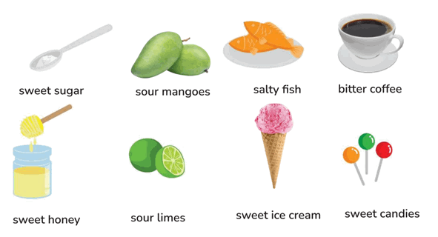
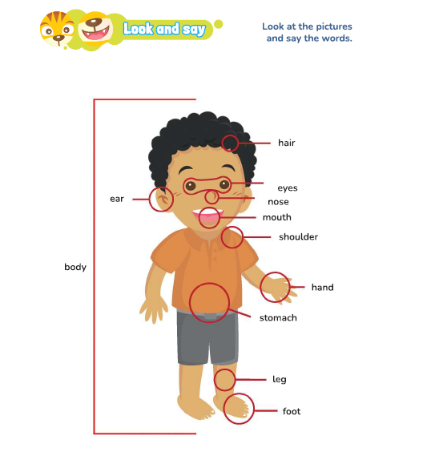
        - what a Delicious

English | Arti | Example Sentence
Sweet | Manis | Ice cream tastes sweet
Sour | Asam | Lemon tastes sour
Salty | Asin | Chips taste salty
Bitter | Pahit | Coffee tastes bitter
Spicy | pedas | Chili tastes spicy.

Text 1
Yesterday was my birthday. My mother made a big chocolate cake for me. The cake tasted sweet and delicious. My father brought some salty chips and spicy noodles. We also had orange juice, and it tasted a little sour. I was so happy because all the food was tasty and my friends enjoyed it too.

- How tall are you
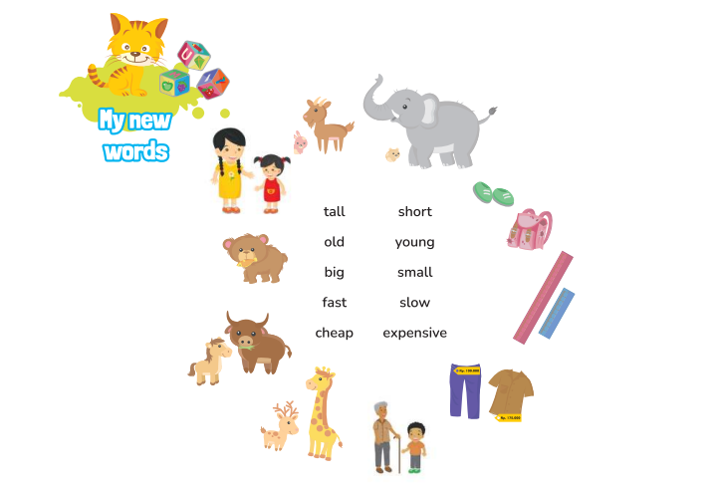

English | Arti | Example Sentence
Tall | Tinggi | The giraffe is tall.
Short | Pendek | The rabbit is short.
Big | Besar | The elephant is big.
Small | Kecil | The mouse is small.
Long | Panjang | The river is long.
cheap | Murah | This shirt is cheap
Dirty | Kotor | The shoes are dirty.
New | Baru | This bag is new.
Clean | Bersih | The classroom is clean.
Old | Tua | That house is old.
Young | Muda | The girl is young.
High | Tinggi (tempat) | The mountain is high.
Low | Rendah | The chair is low.
Expensive | Mahal | That phone is expensive

- what a nice skirt?
English | Arti | Example Sentence
Buy | Membeli | We buy clothes at the shop.
Wear | Memakai | i wear a red skirt
Run | Lari | I run home to show my new skirt
Play | Bermain | I play with my friends
See | Melihat | They see new shoes in the store.
Like | Menyukai | I like these shoes

Palu,28 Mei 2025

Mengetahui :
Guru Bahasa Inggris |  | Researcher
Tisa Triana Ruung, S.Pd |  | Nanda Amaliah  Nim. 211160008

Appendix 2
PRE-TEST
Name:
Class:
CHOOSE THE CORRECT ANSWER BY CROSSING (X) A, B, C OR D!
Pilihlah Jawaban Yang Benar Dengan Memberi Tanda Silang (X) Pada A, B, C atau D!

- Rian is drinking his coffee. The taste is . . .
- better c. bitter
- hungry d. fast

- It is a chocolate.
a. book b. small
c. Sweet d. drink

The following text is for questions number 3-5

Hello, my name is Dina. I want to tell you about the taste of my favorite food. My favorite food is pizza. It tastes savory and delicious. Usually, this food is eaten for lunch or dinner. Pizza is simple and tasty. It is made of bread, cheese, tomato sauce, and various toppings like pepperoni or vegetables.

- Dina's favorite food is _____.
a. sweet b. pizza c. small d. eat

- Pizza tastes _____ and delicious.
a. writing b. bread c. savory d. eyes

- Pizza is made of _____, cheese, tomato sauce, and toppings.
a. swimming b. bread c. spicy d. tall

- Made wearing a . . .

a. play b. uniform c. sweet d. hands

- My favorite activity is…. (berpergian).
- Spicy b.Traveling c. drawing d. hands

- I love book in the evening.
a. pencil c. searching
b. reading d. short

- They _____ a beautiful song in the class. (menyanyi)
a. sing b. happy
c. dance d. small

- We _____ our favorite movie on TV. (menonton)
a. watch b. happy
c. play d. chair

Match the question in column A with the correct answer in column B. Choose the correct letter A, B, C,and D

Column A | Column B
What do you use to see? | - Ears  - Eyes  - Hair  - Head

- Which answer matches the question?
- C. Hair b. A. Ears c. D. head d. B. eyes

Column A | Column B
What part of the body do we use to taste? | - Ears  - Chest  - Stomach  - Tongue

- Which answer matches the question?
a. B. chest b. A.ears c. D.tongue d. C. stomach

- When you’re hungry, what do you do?
a. walk b. eat
c. strong d. Short

- What part of body shown on the picture below?
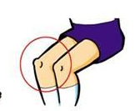
- legs b. knee
- chest d. cheek

- Grandfather is but cici is young
- short
- lamp
- Small
- old
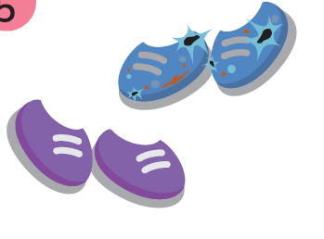
- The purple shoes are ….,
But the blue shoes are old.
  - expensive b. cheap
  - dirty d. new

- The car is ….,
But the bike is slow.
a. Flat b. new c. clean d. fast

- The book is ….,
But the pencil is short.
a. simple b. flat c. long d. write

- The mountain is high,
But the hill is ………..
a. Low b.look c. flat d. small

- Which one do you use to write on the whiteboard
- Writing
- Marker
- Pen
- crayon

Source:Adapted of the question provided by the English teacher

LEMBAR KERJA JAWABAN PRE TEST
Name:
Class:
CHOOSE THE CORRECT ANSWER BY CROSSING (X) A, B, C OR D!
Pilihlah Jawaban Yang Benar Dengan Memberi Tanda Silang (X) Pada A, B, C atau D!

1 | A | B | C | D
2 | A | B | C | D
3 | A | B | C | D
4 | A | B | C | D
5 | A | B | C | D
6 | A | B | C | D
7 | A | B | C | D
8 | A | B | C | D
9 | A | B | C | D
10 | A | B | C | D
11 | A | B | C | D
12 | A | B | C | D
13 | A | B | C | D
14 | A | B | C | D
15 | A | B | C | D
16 | A | B | C | D
17 | A | B | C | D
18 | A | B | C | D
19 | A | B | C | D
20 | A | B | C | D

ANSWER KEY PRETEST

- C | - D
- C | - C
- B | - B
- C | - B
- B | - D
- B | - D
- B | - D
- C | - C
- A | - A
- A | - A

Assesment
Technique: students answer multiple choice
Form: multiple choice Scoring
Guidance
- right answer = 1
- wrong /unfilled answer
- Score Maximum = 20

𝑆𝑡𝑢𝑑𝑒𝑛𝑡𝑠 ′ 𝑠𝑐𝑜𝑟𝑒 = 𝑡𝑜𝑡𝑎𝑙 𝑟𝑖𝑔ℎ𝑡 𝑎𝑛𝑠𝑤𝑒𝑟 × 100
20

Appendix 3
POSTEST
Name:
Class:
CHOOSE THE CORRECT ANSWER BY CROSSING (X) A, B, C OR D!
Pilihlah Jawaban Yang Benar Dengan Memberi Tanda Silang (X) Pada A, B, C atau D!

- The taste of chili is …
a. bitter b. salty c. Spicy d. sour
- A: How does lemon taste?
B: It tastes …
a. Hour b. Sour
c. sweet d. salty
The following text is for questions number 3-4

Hello, my name is Rian. My favorite food is pizza. It’s yummy and cheesy. I like to eat it with my friends. I love to drink juice. It’s sweet and fresh. For breakfast, I eat cereal. It’s crunchy and tasty.

- I love to juice.
a. laugh b. Drink c. salty d. eat

- I eat ______ for breakfast.
a. Cereal b. yummy c. Bitter d.pizza
- Look at the picture below!
made is wearing a . . . .
a. jacket b. shirt c. T-shirt d. pants
- My hobby is . . . . (berenang).
a. study b. Swimming c. eating d. learning
- I like a diary in the evening.
a. wait
b. teach
c. jump
d. Write

Match the question in column A with the correct answer in column B. Choose the correct letter A, B, C,and D

Column A | Column B
What part of the body do we use to talk?
  - shoulder
  - Mouth
  - knee
  - finger

- Which answer matches the question?
a. D. Finger b. B. Mouth c. A. Shoulder d. C. Knee

Column A | Column B
What part of the body do we use to touch things?
      - Mouth
  B. Hand
  C. Hair
  - Tooth

- Which answer matches the question?
a. D. Tooth b. C. Hair c. B. Hand d. A. Mouth

- I _____ to school every morning. (berjalan)
a. sleep b. tall c. walk d. close
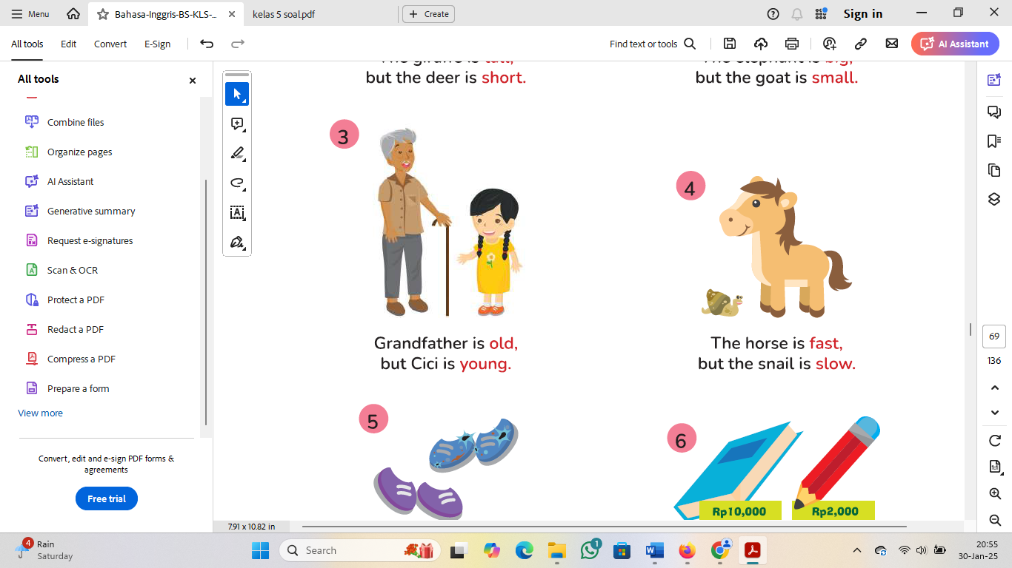
- The horse is fast but the snail is ?
a. flat b. smile
c. small d. slow
- The goat is But elephant is big
a. flat b. tall
c. small d. short
- The book is but
the pencil is cheap
  - small
  - wide
  - clean
  - expensive

- I _____ with my foot. (lompat)
a. jump b. bring c. walk d. long

- What do you use to walk?
a. ear b. Legs c. hair d.mouth

- When you are cold, what do you wear?
a. Jacket b. dress c. belt d. tie

- When you are tired, what do you do?
a. Sleep b. walk c. jump d. laugh

- We _____ English in the classroom. (belajar)
a. study b. write c. bring d. tell

- Tom is in the kitchen. He is his mother cook dinner.
a. drawing b. dance c. helping d. old

- You wear this on your feet.
a. hat b. skirt c. shoes d. sweater

Source:Adapted of question provided by the English teacher

LEMBAR KERJA JAWABAN POST TEST
Name:
Class:
CHOOSE THE CORRECT ANSWER BY CROSSING (X) A, B, C OR D!
Pilihlah Jawaban Yang Benar Dengan Memberi Tanda Silang (X) Pada A, B, C atau D!

1 | A | B | C | D
2 | A | B | C | D
3 | A | B | C | D
4 | A | B | C | D
5 | A | B | C | D
6 | A | B | C | D
7 | A | B | C | D
8 | A | B | C | D
9 | A | B | C | D
10 | A | B | C | D
11 | A | B | C | D
12 | A | B | C | D
13 | A | B | C | D
14 | A | B | C | D
15 | A | B | C | D
16 | A | B | C | D
17 | A | B | C | D
18 | A | B | C | D
19 | A | B | C | D
20 | A | B | C | D

ANSWER KEY POST TEST

- C | - D
- B | - C
- B | - D
- A | - A
- C | - B
- B | - A
- D | - A
- B | - A
- C | - C
- C | - C

Assesment
Technique: students answer multiple choice
Form: multiple choice Scoring
Guidance
- right answer = 1
- wrong /unfilled answer
- Score Maximum = 20

𝑆𝑡𝑢𝑑𝑒𝑛𝑡𝑠 ′ 𝑠𝑐𝑜𝑟𝑒 = 𝑡𝑜𝑡𝑎𝑙 𝑟𝑖𝑔ℎ𝑡 𝑎𝑛𝑠𝑤𝑒𝑟 × 100

Appendix 5
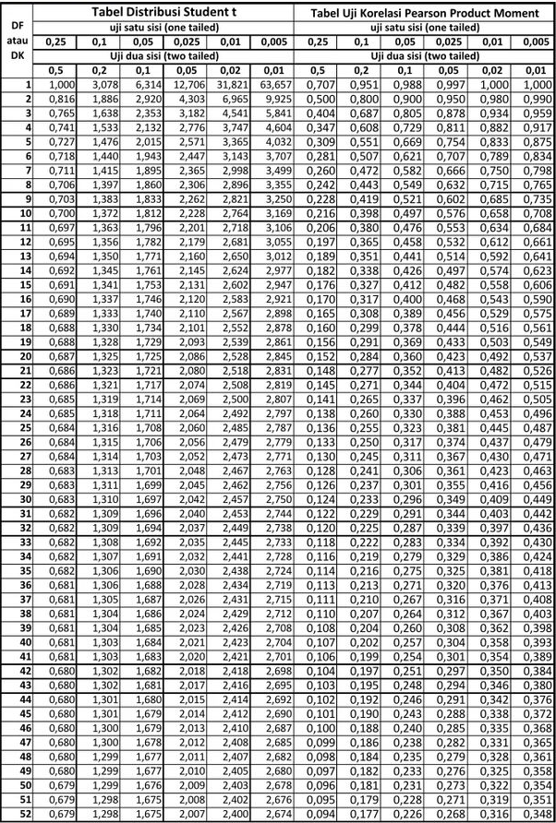
T-Table
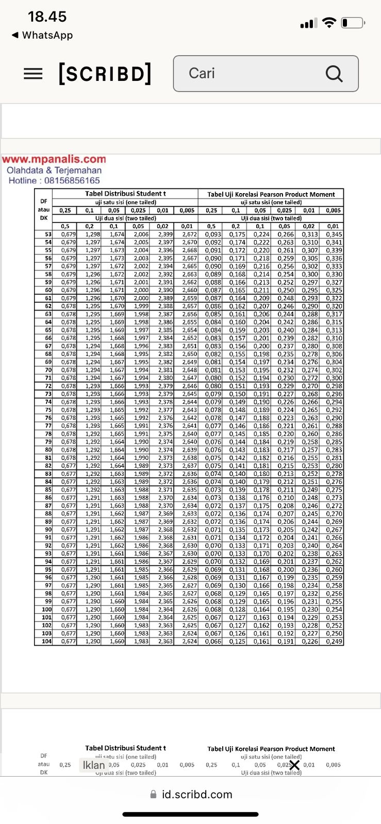
Appendix 6 DOCUMENTATION

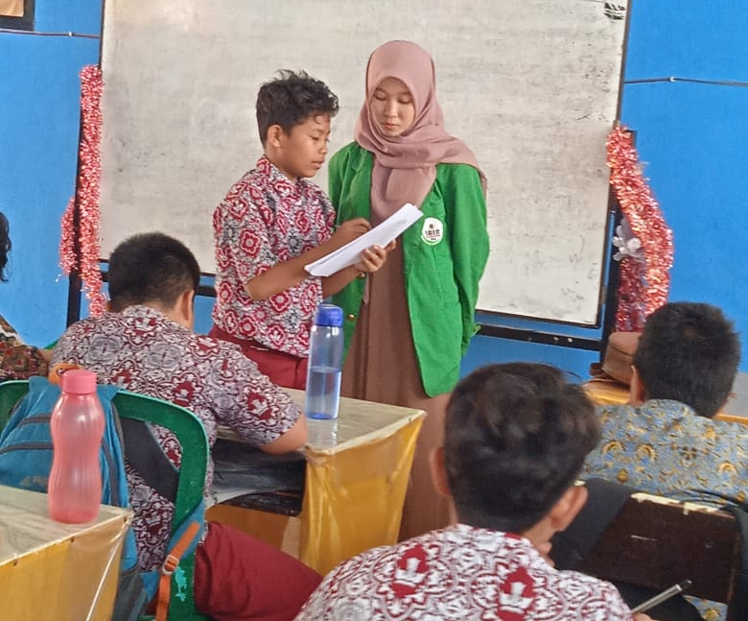
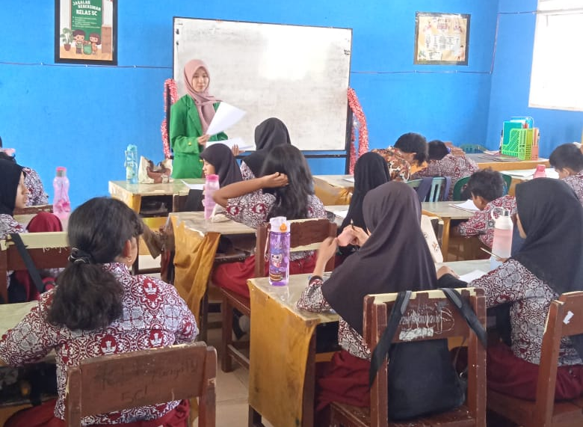
Giving pre-test to the experiment class

Giving pre-test to the control class
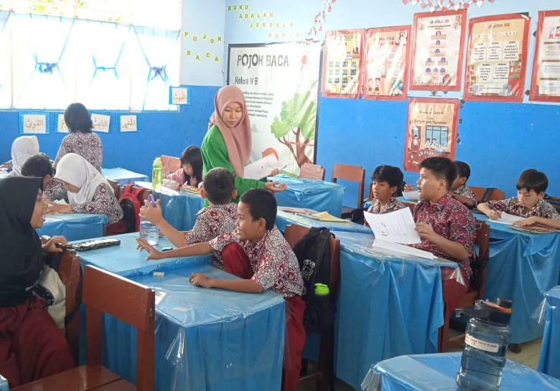
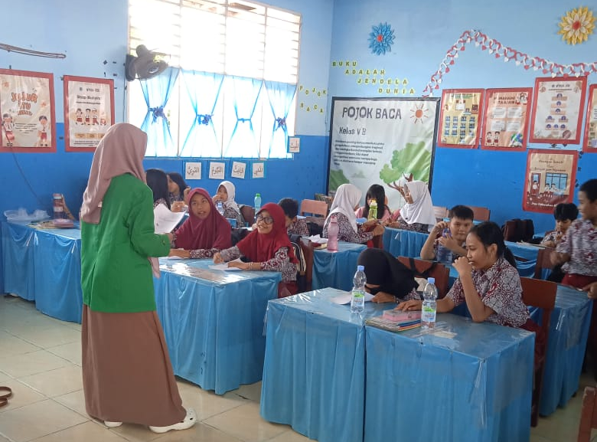

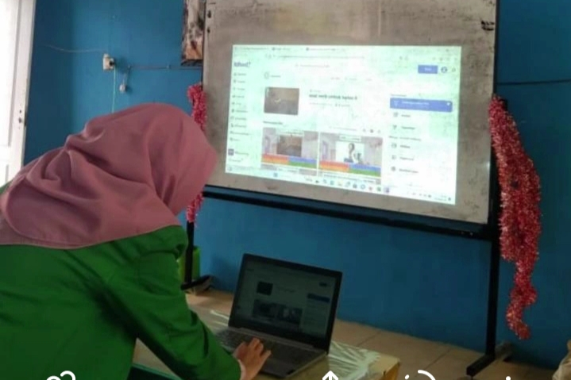
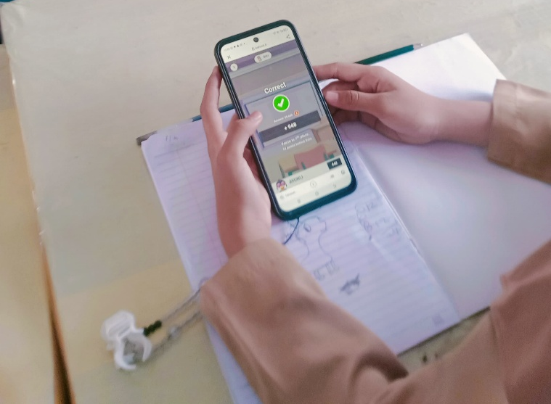
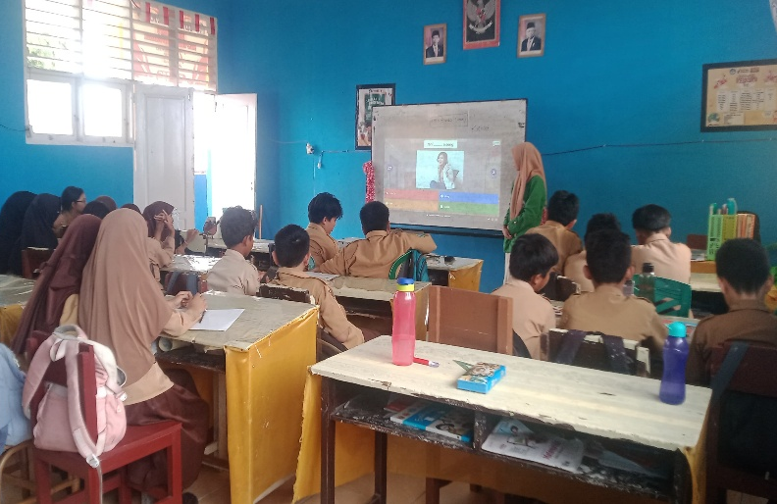
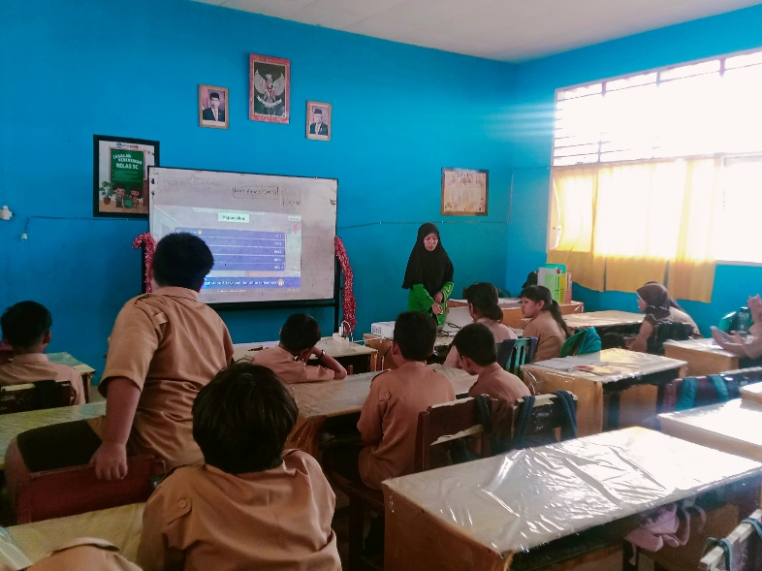
Giving treatment to the experiment class using Word Trip Application
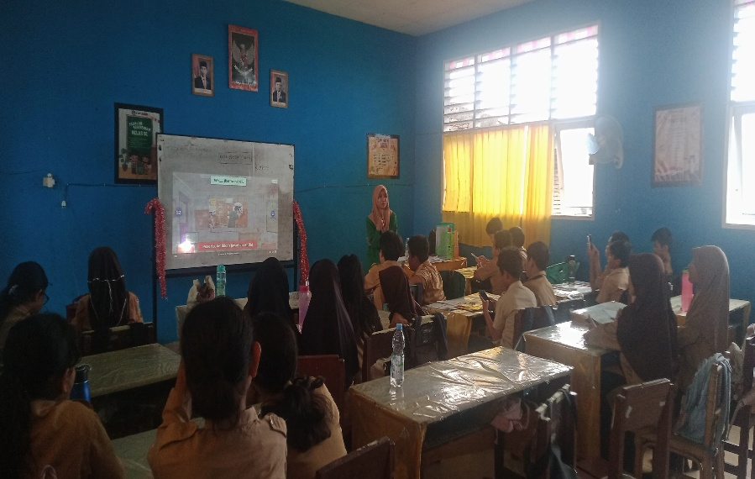
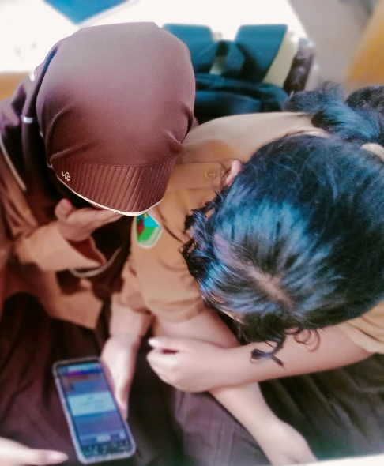
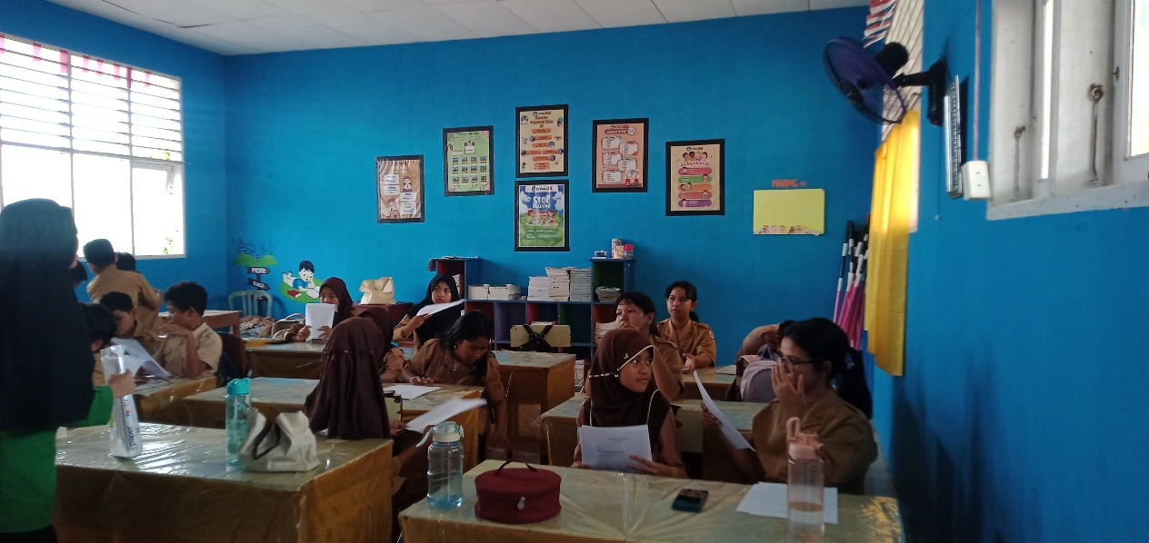
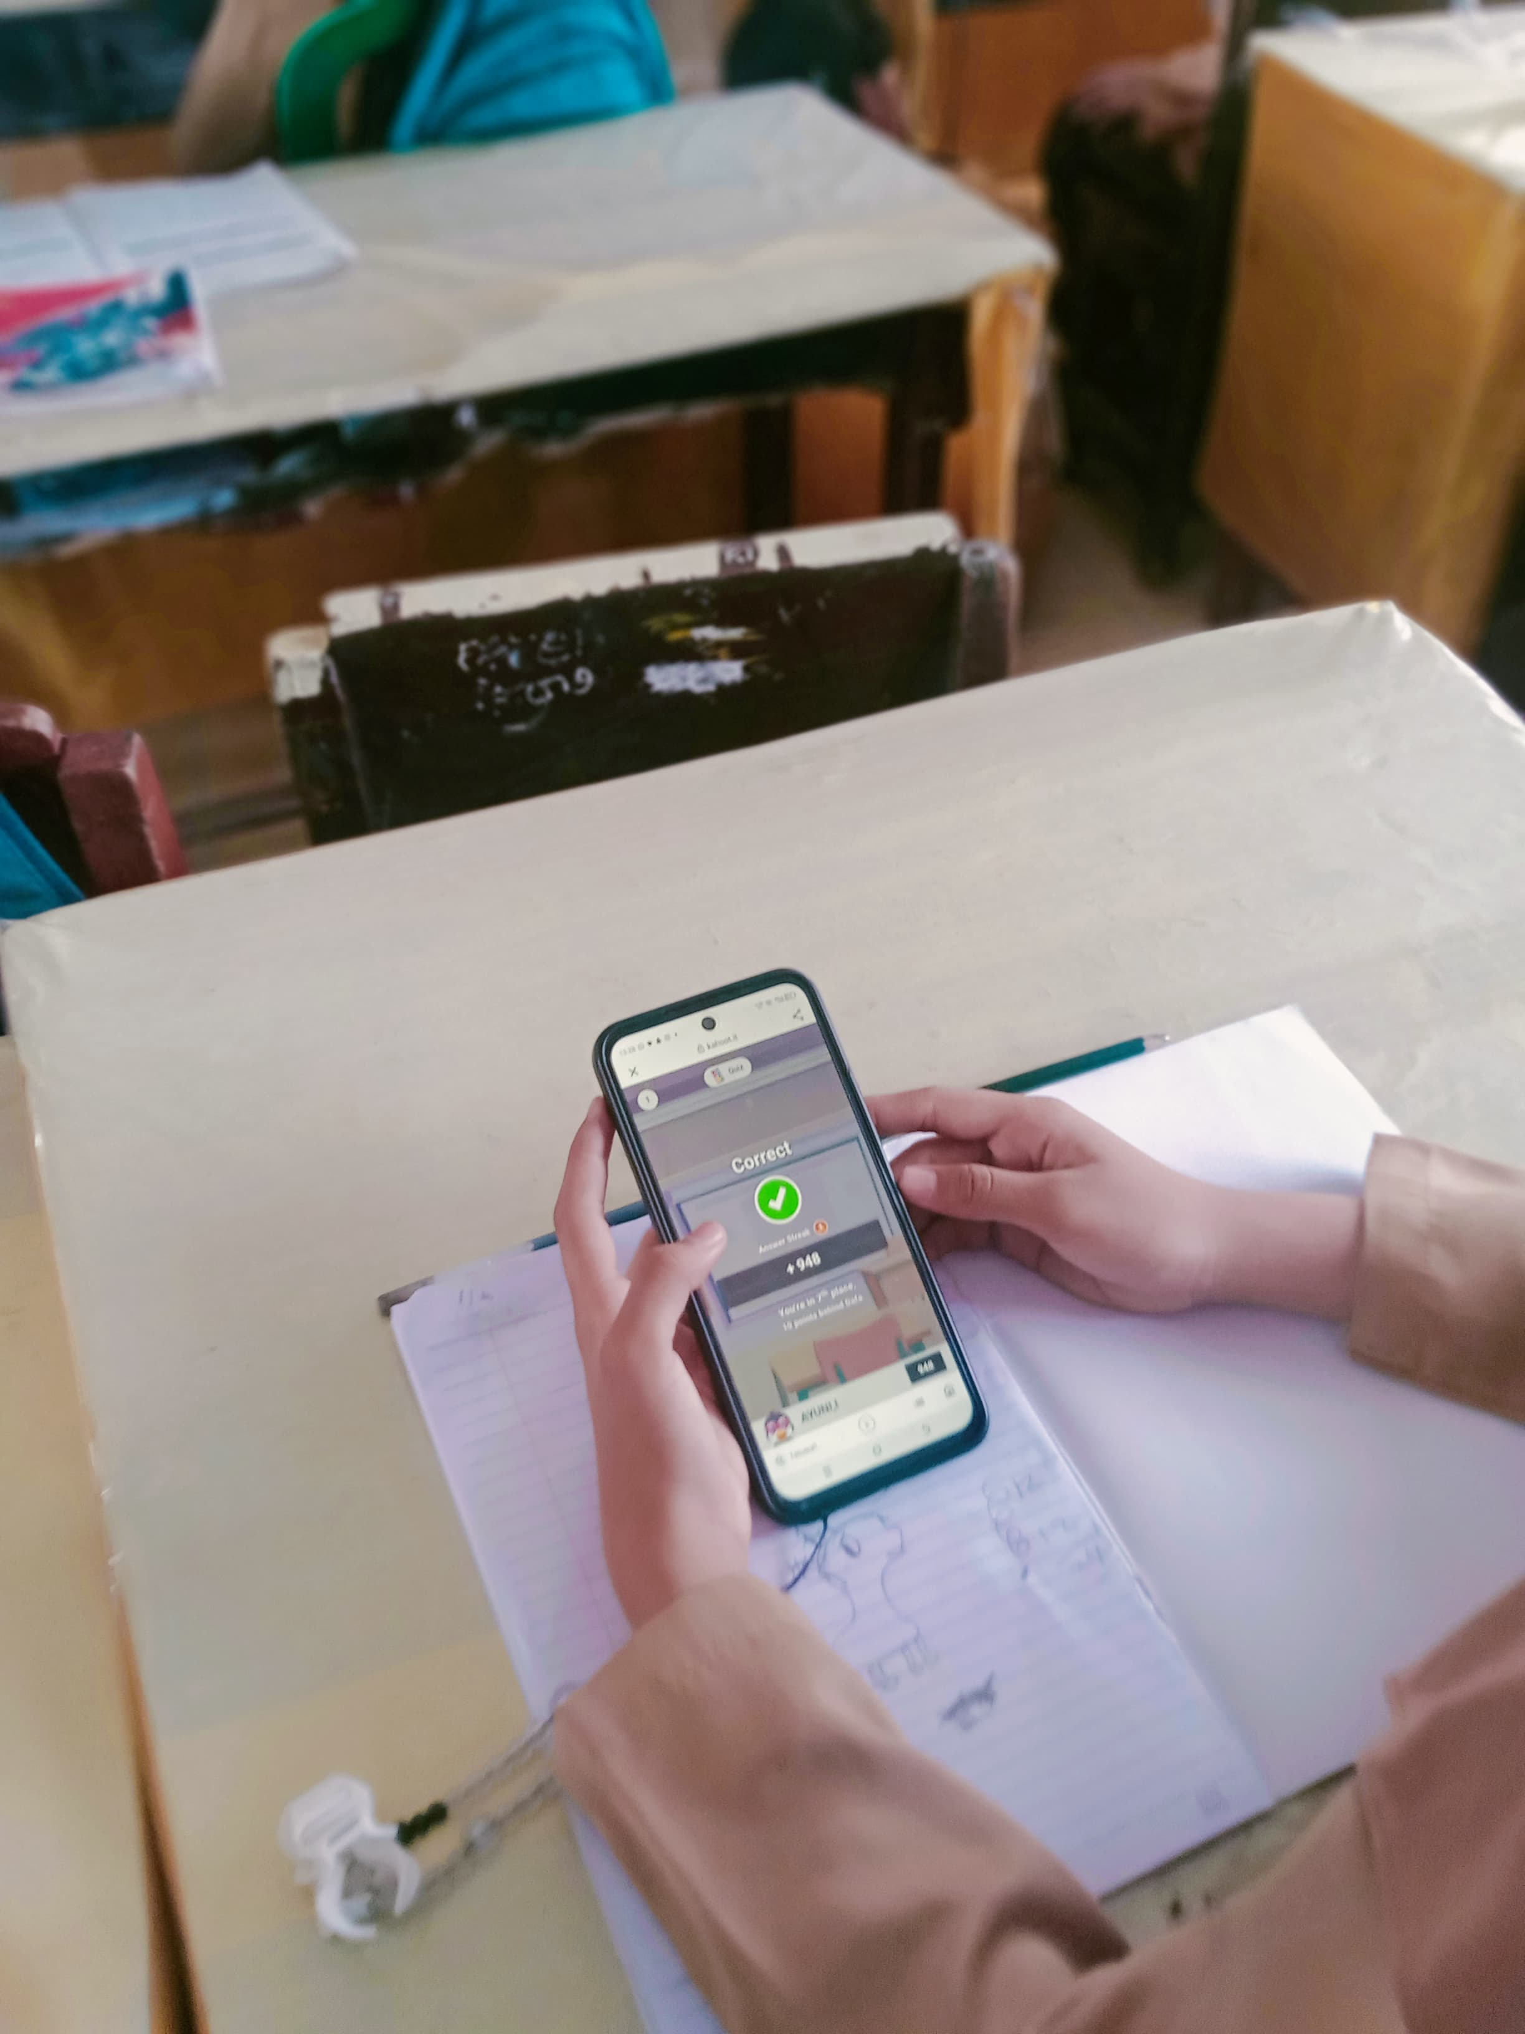
Giving post-test to the experiment class

Giving post-test to the control class
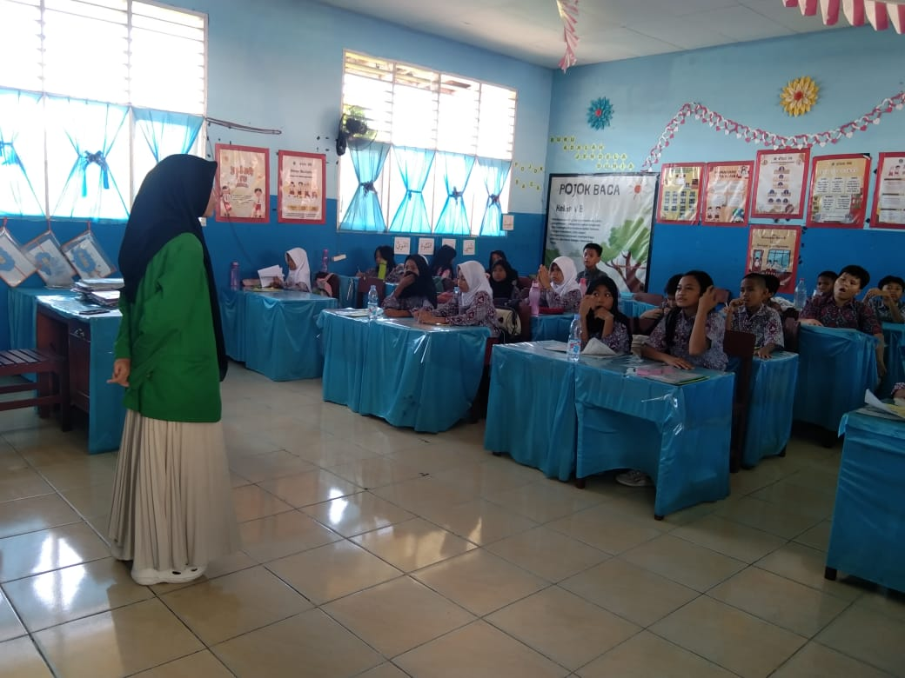

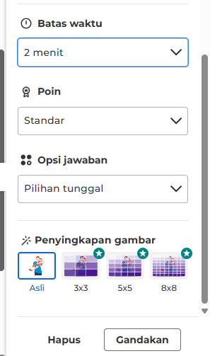
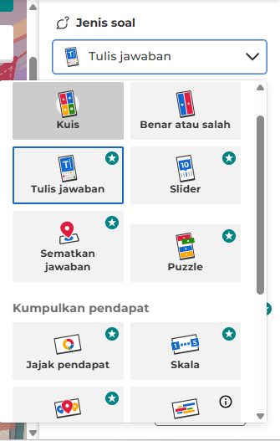
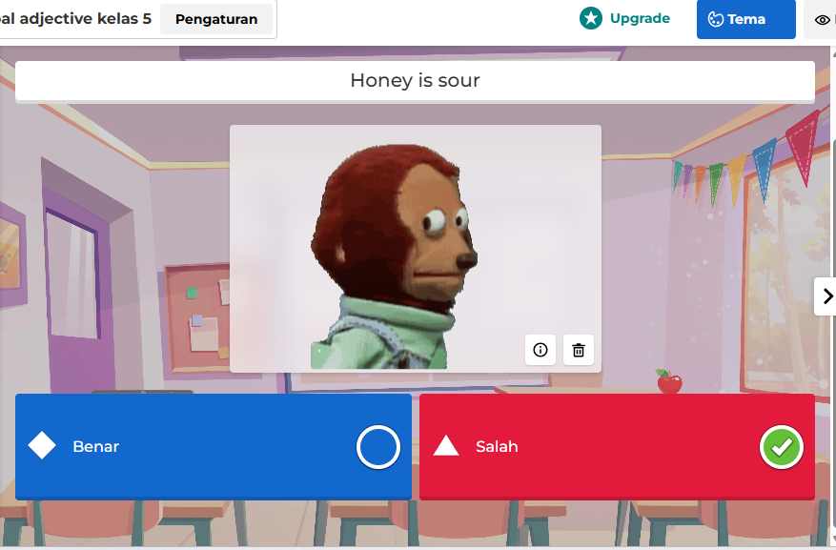
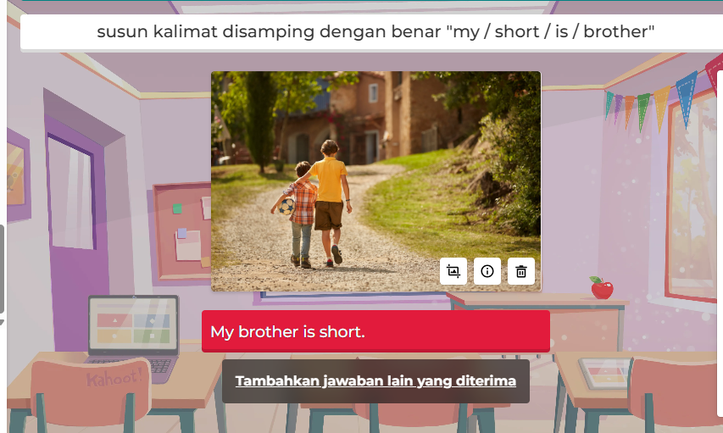
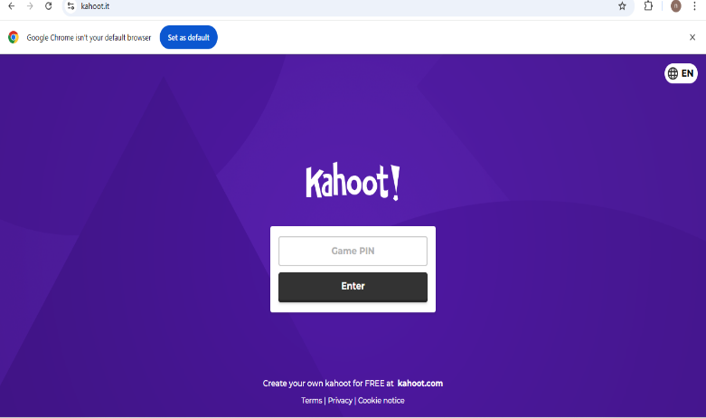
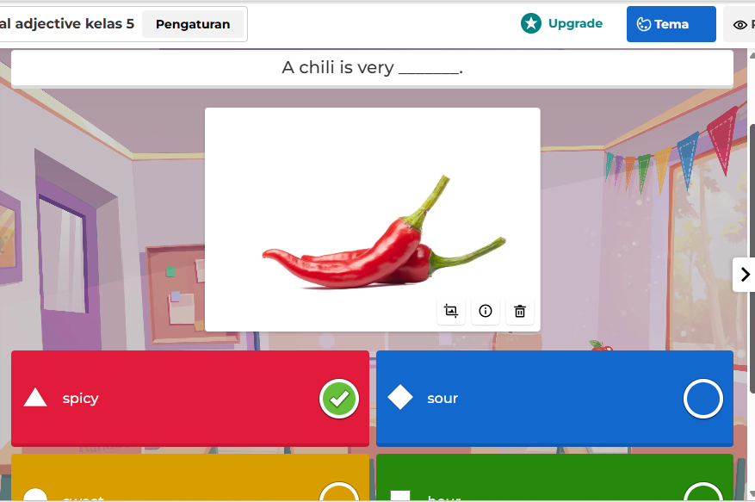
Appendix 7 Kahoot Features

Appendix 8 Surat Izin Penelitian
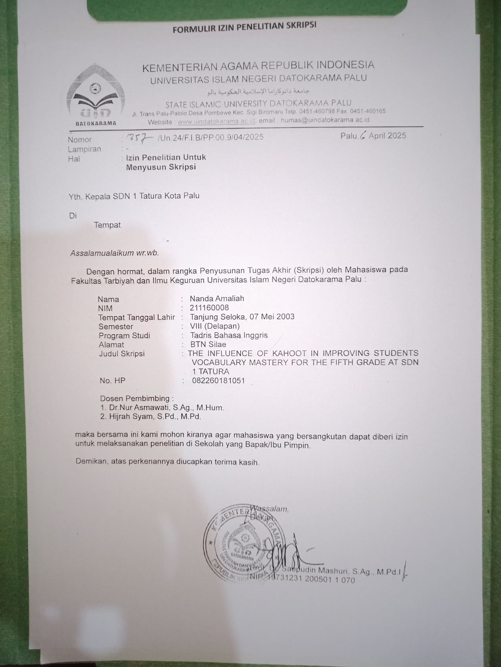

Appendix 9 Surat Keterangan Selesai Meneliti
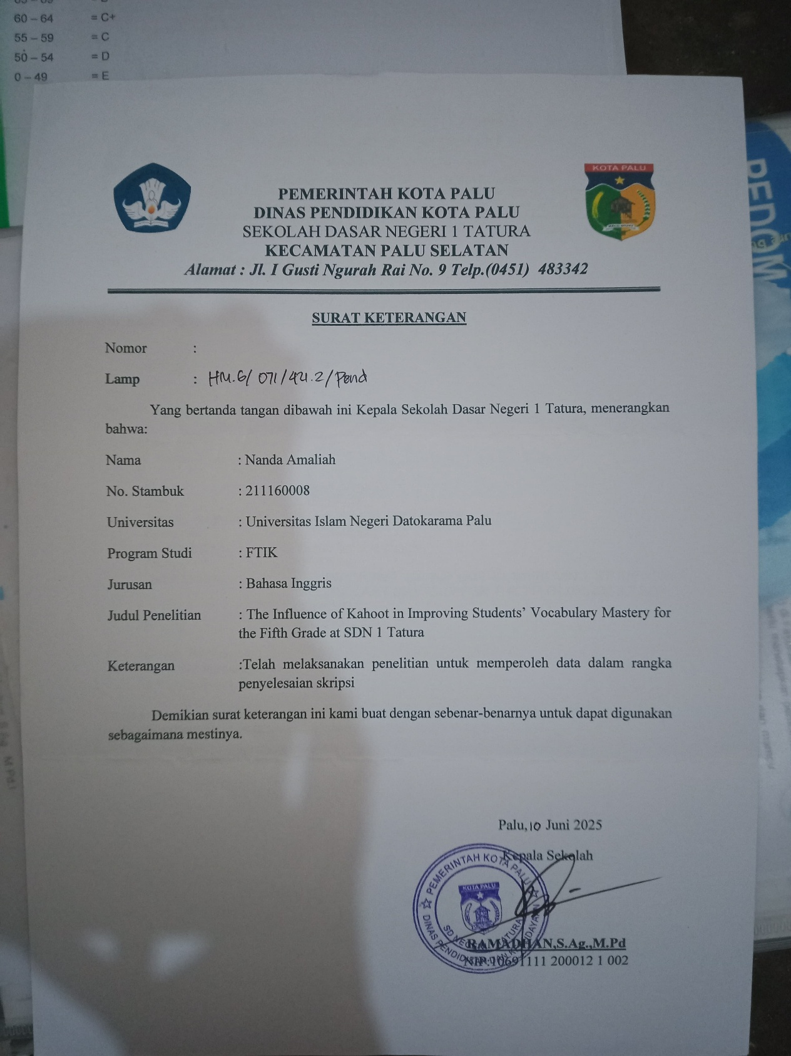

Appendix 10 Pengajuan Judul

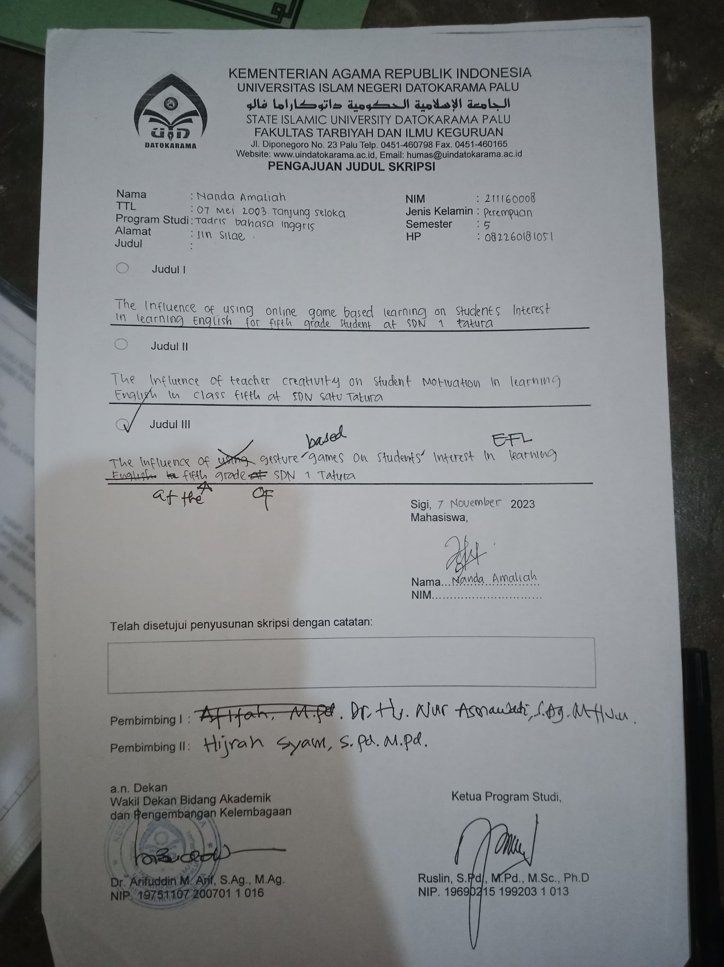

Appendix 11 Penetapan Dosen Penguji Proposal


Appendix 12 Undangan Seminar Proposal
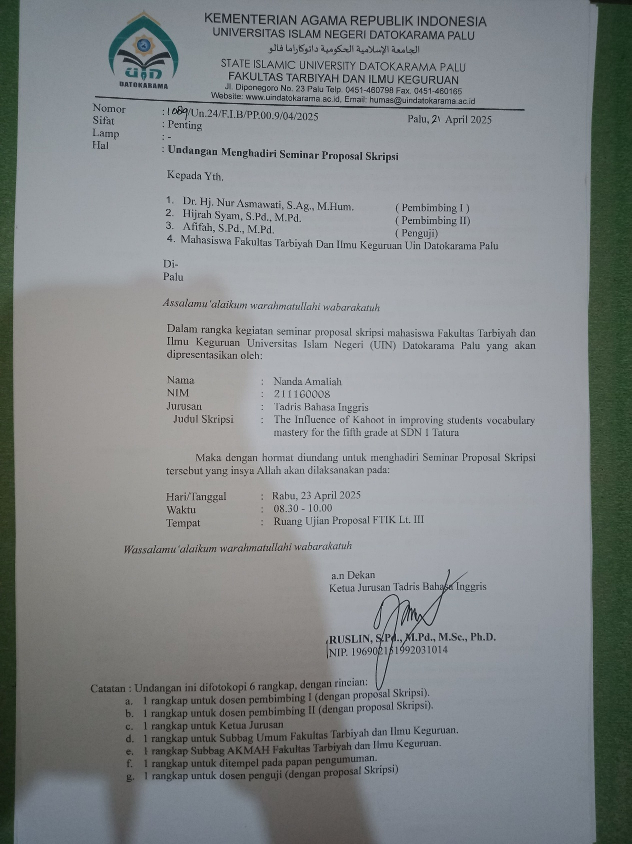

Appendix 13 Kartu Seminar Proposal

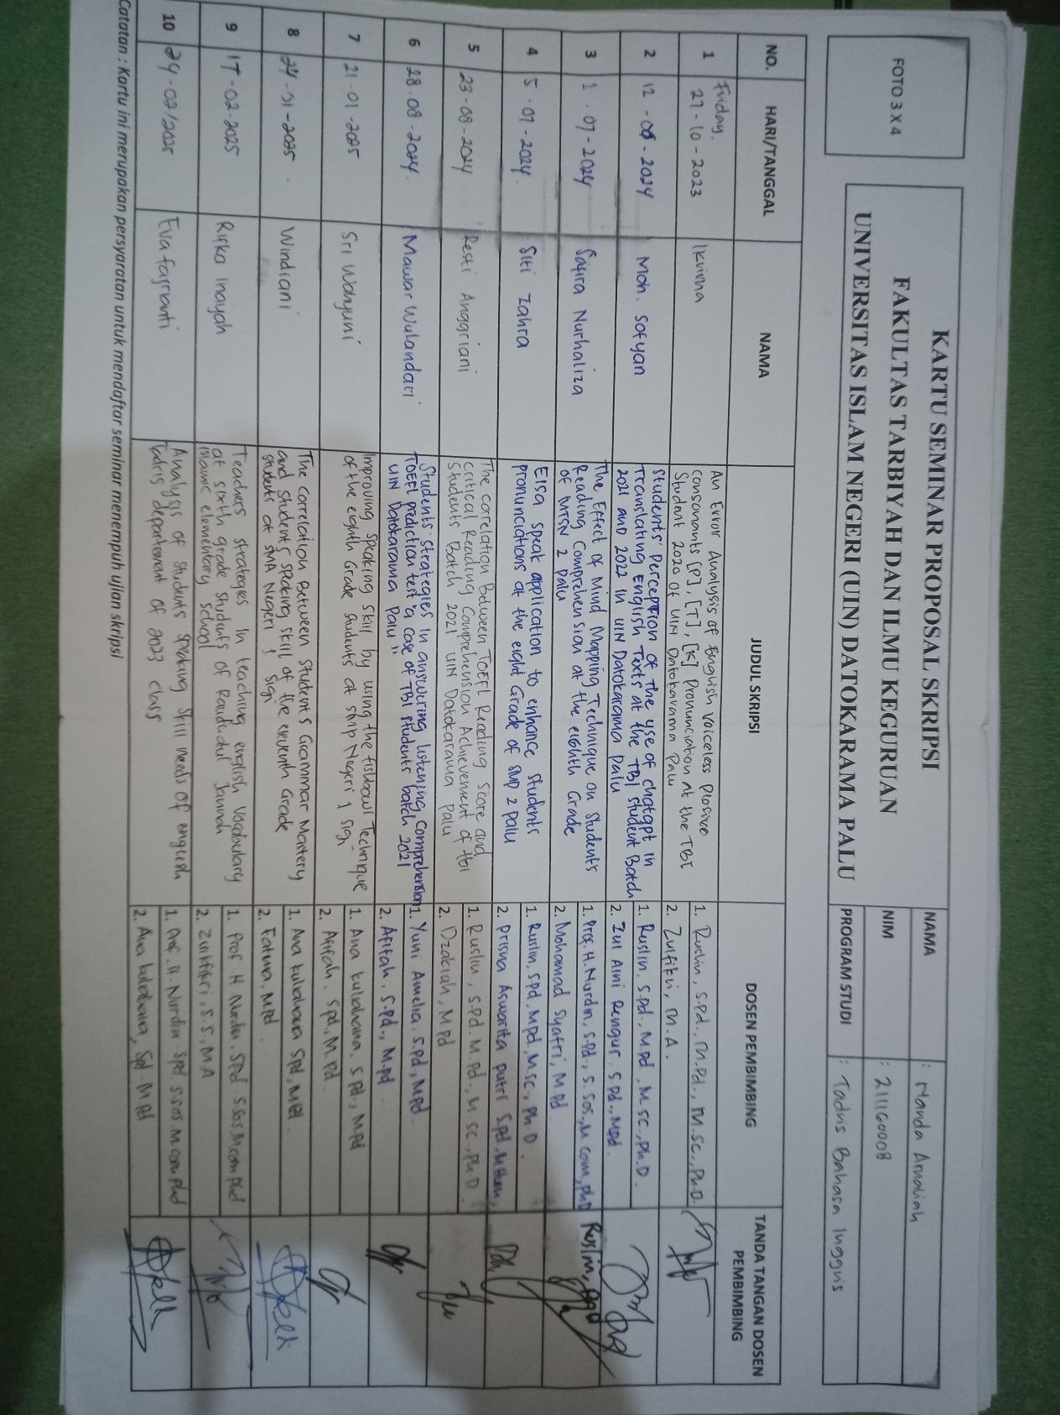

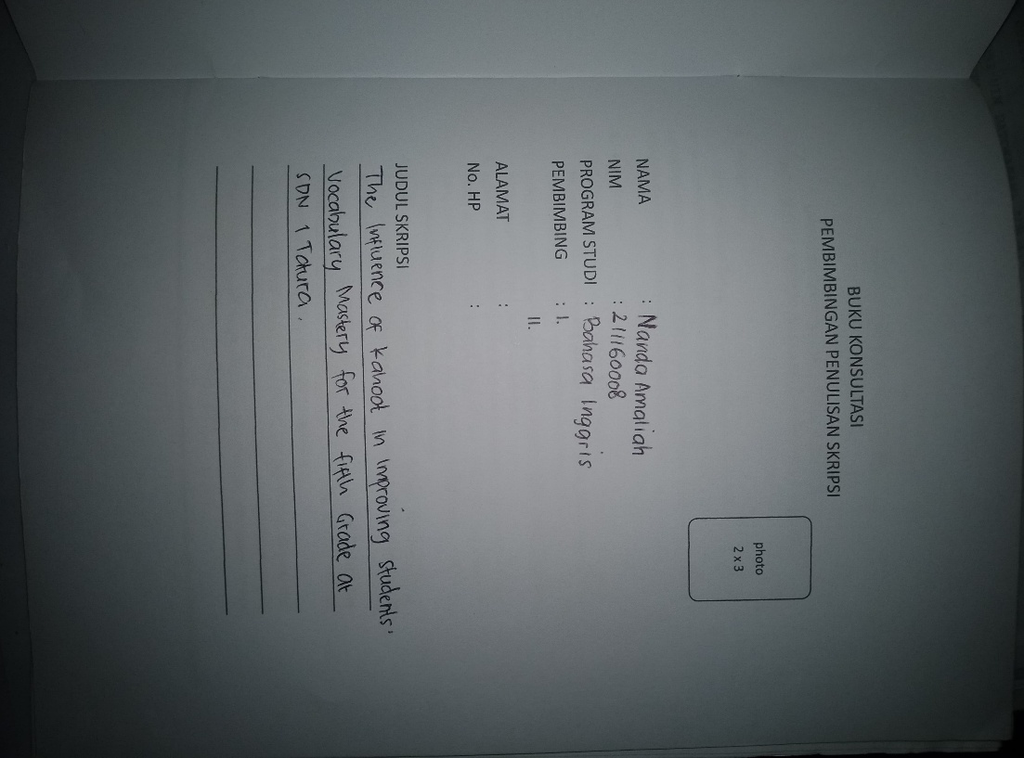
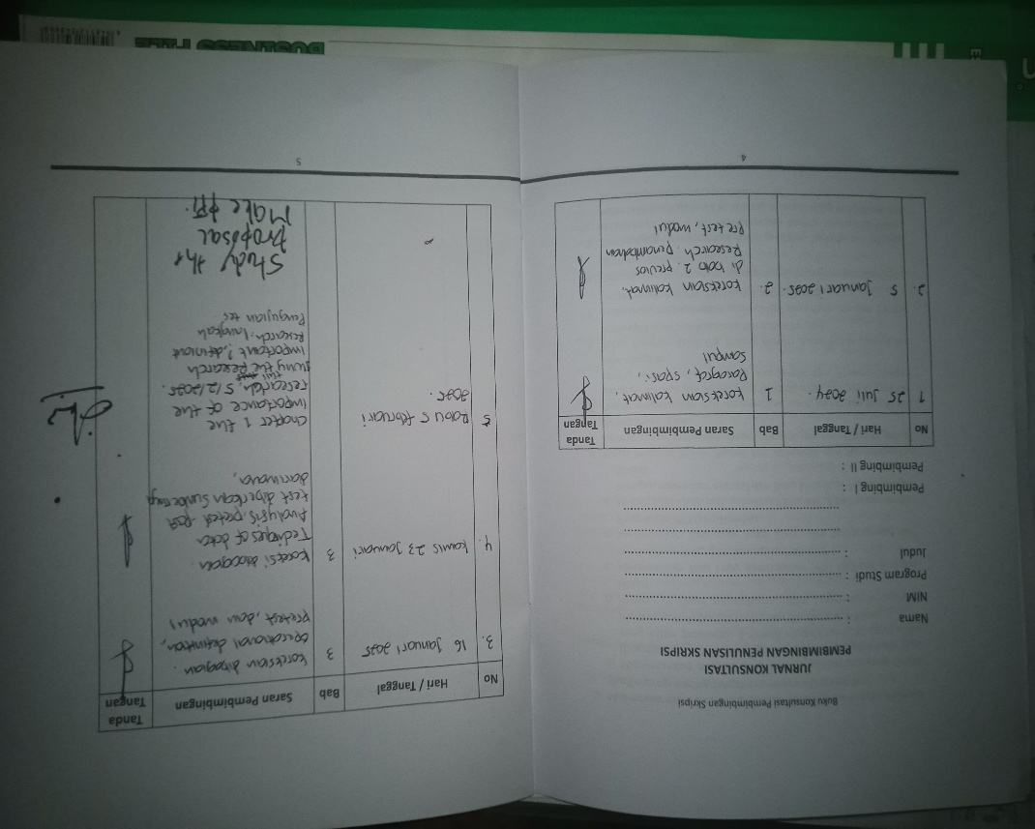
Appendix 15 Bukti Bimbingan

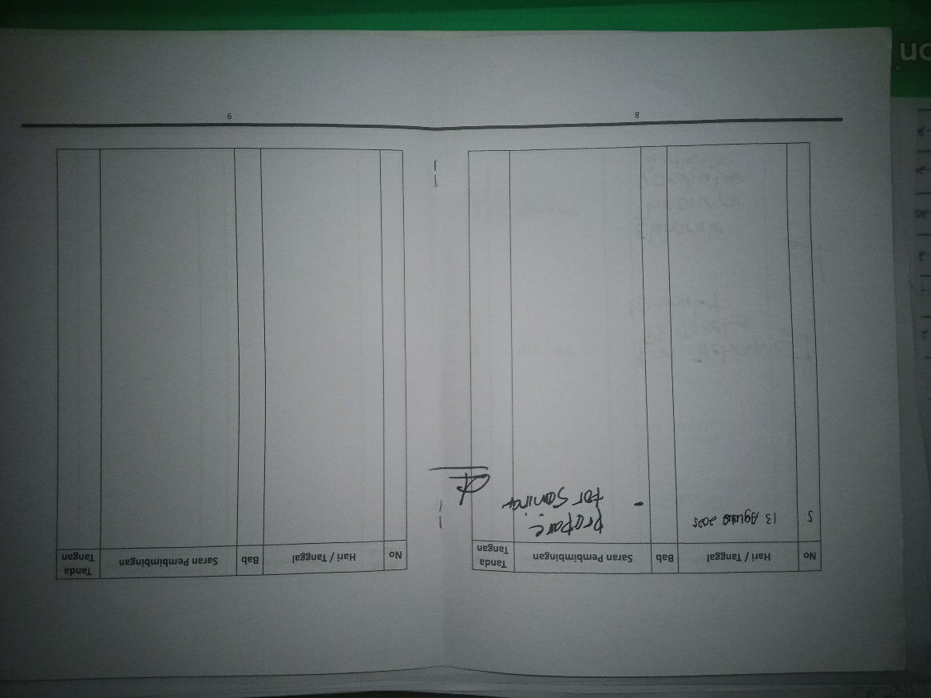
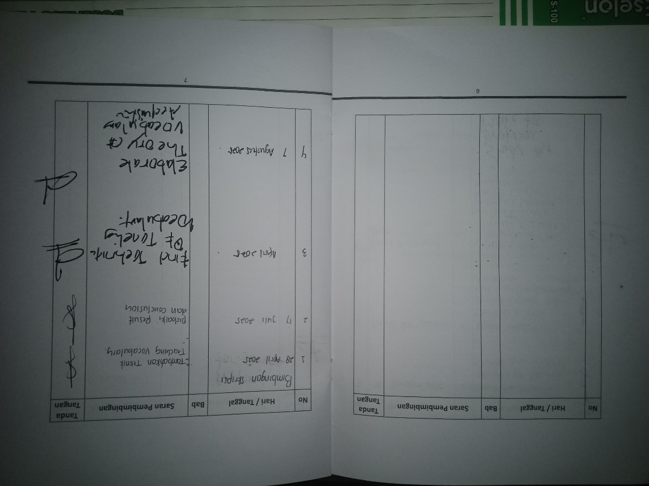

CURRICULUM VITAE


- Research Identify
Name | : Nanda Amaliah
Place and Date of Birth | : Tanjung Seloka, 07th May 2003
Gender | : Female
Religion | : Islam
Departement | : English Tadris Program
Faculty | : Tarbiyah and Teacher Trainig Faculty
Number of Student | : 21.1.16.0008
Address | : BTN Silae
E-mail | : amaliahnanda272@gmail.com
- Parents Identify
- Father
Name | : Ihsan
Profession | : Karyawan swasta
Address | : Kotabaru, Kalimantan Selatan
- Mother
Name | : Fitriah
Profession | : Housewife
Addres | : Kotabaru, Kalimantan Selatan
- Educational
- SD LAUT TIMUR | : Graduate in 2014
- SMPN 1 LAUT SELATAN | : Graduate in 2018
- MAS LIL BANAT | : Graduate in 2021

Ella Masita, “Kurikulum Merdeka dan Pengajaran Bahasa Inggris di Era Digital”, Litnus, (2024)
Ibid,2
Husnul Huda, Nuna Mustikawati Dewi, Lulut Widyaningrum. “Mengemas Kelas Bahasa Inggris (EFL) melalui Joyful Learning Based Social Constructivism Pedagogy” Jurnal Pengabdian Masyarakat, 17, no. 2, (2017)
Rachmah Amalia. “Kesulitan Penguasaan Kosakata Bahasa Inggrispada Siswa Sekolah Dasar” jurnal Pendidikan.2 no 1 (2023).289.
Harmer, J. Praktik pengajaran bahasa Inggris (4th Ed.). Harlow: Longman. (2007)
Yusran Pora, Develop Your Vocabulary, Grammar and Idiom, (Yogyakarta: Pustaka Pelajar, 2007, 2007)511
Purwanti, R. “Pembelajaran Bahasa Inggris Untuk Anak Usia Dini Melalui Metode Gerak danLagu. Jurnal Ilmiah Potensia”, 5 no 2. (2020)91-105.
Michael Lewis “Implementing the Lexical Approach: Putting Theory into Practice” Heinle Cengage Learning. (1997)
Ismail, M. A. A., & Mohammad, J. A. M. “Kahoot: A Promising Tool for Formative Assessment in Medical Education”. Education in Medicine Journal (2017) 9(2), 19–26
Licorish, S. A., Owen, H. E., Daniel, B., & George, J. Students’ Perception of Kahoot!’s Influence on Teaching and Learning. Research and Practice in Technology Enhanced Learning (2018), 13(9), 1–23.
E. W. Dolch “A Basic Sight Vocabulary” The Elementary School Journal, Vol. 36, No. 6 (2009)
Fajar Muhammad, Rizky “The use of Kahoot! Game on student’s vocabulary knowledge”. Faculty of Educational Sciences (2021)
Neilan Sabila Awaludin, Lungguh Halira Vonti, Iyan Irdiyansyah “The use of Kahoot application on students’ vocabulary mastery” journal of English Language Studies (2022)
Lidya Febriani, Merry Prima Dewi, Syahrul, Widya Syafitri “The Effect of Using Kahoot Application to Retain Students’ Vocabulary at the Second Grade of SMPN 3” Jurnal Pendidikan Tambusai. 8 no 1 (2022) 1193-1198
Jack C Richards and Willy A. Renandya. “Methodology in Language Teaching” Cambridge: Cambridge University Press. (2002), 255.
Evelyn Hatch and Cheryl Brown. “Vocabulary, Semantic and Language Education” Cambridge: Cambridge University Press. (2001), 1.
E. W. Dolch “A Basic Sight Vocabulary” The Elementary School Journal, Vol. 36, No. 6 (2009)
Er Dewi “Pengembangan Media English Card Vocabulary dalam Pembelajaran Kosakata Bahasa Inggris untuk Siswa Kelas III SDN Dinoyo 3 Malang”.2017
Scott Thornbury. “How to Teach Vocabulary” England: Person Education Limited (2002)
Scott Thornbury. “How to Teach Vocabulary” England: Person Education Limited (2002)
Hornby. Advance learner’s dictionary. New York: Oxford University Press. (1995)
Nur Rahmah, M, Tahir and A. Talib, “The Effect of Vocabulary Mastery on Students’ Reading Comprehension” International Journal of Business, English, and Communication (2022) 38.
Virginia French Allen, “Techniques in Teaching Vocabulary” Oxford: Oxford University Press. (1983), 10-13.
Darren H. Iwamoto et al. “Analyzing the Efficacy of the Testing Effect Using Kahoottm On Stident Performance”, Turkish Online Journal Of Distance Education-TOJDE, (2017) 82.
khabidin. “Efektifitas penerapan aplikasi kahoot dalam mengkondisikan kelas pada mata pelajaran pendidikan agama islam di smp n 1 pagentan kabupaten banjarnegara”. (2019) 4
Ibid, 5
Halimatus Solikah, “Pengaruh Penggunaan Media Pembelajaran Interaktif Quizizz terhadap Motivasi dan Hasil Belajar Siswa pada Materi Teks Persuasif Kelas VIII di SMPN 5 Sidoarjo Tahun Pelajaran 2019/2020”. Jurnal Mahasiswa Unesa.(2020) 2
Ibid, 3
Suyidno. “Pelatihan Media Berbasis E-learning Menggunakan Kahoot! untuk Guru Fisika”. Jurnal Pengabdian Masyarakat. 1 No 1 (2019). 9-14
Sugiyono, “Metode Penelitian Pendidikan”. Alfabeta. Bandung.2016
Creswell, John W “Research Design Qualitative, Quantitative, and Mixed Methods Approaches”. United States. (2018), 51
Emzir, Metodologi Penelitian Pendidikan: Kuantitatif & Kualitatif, (Depok: Rajawali Press,2017),64
Ary Donald, Lucy Cheser Jacobs, and Chris Sorensen, Introduction to Research in Education, English Edition (USA; Wadsworth, Cengange Learning,2010),316.
John W. Creswell, “Educational Research: Planning, Conducting, and Evaluating Quantitative and Qualitative Research” University of Nebraska: Lincoln, (2012). 142
John W. Creswell, “Educational Research: Planning, Conducting, and Evaluating Quantitative and Qualitative Research” University of Nebraska: Lincoln, (2012). 142
Emzir, Metodologi Penelitian pendidikan: Kuantitatif & kualitatif., (Depok: Rajawali Press, 2017), 25.
Sugiyono, “Metode Penelitian Pendidikan, Pendekatan Kuantitatif, Kualitatifdan R&D”. Bandung: Alfabeta, (2016), 61
John W. Creswell, Educational Research: Planning, Conducting, and Evaluating Quantitative and Qualitative Research (University of Nebraska: Lincoln, 2012), 115.
Ibid, 116
Purwanto. “Teknik penyusunan instrumen uji validitas dan reliabilitas penlitian Ekonomi” (2018) 24
Arikounto, Prosedur Penelitian Suatu Pendekatan Praktik (Jakarta: Rineka Cipta,2002), 143.
Ranjit Kumar, Research Methodology: A Step-by-Step Guide for Beginners, 3rd Edition (California: Sage Publications, Inc., 2011), 166.
Amirotun Sholikhah, Statistik Deskriptif Dalam Penelitian Kualitatif. (2016), 349.
Asrul , Rusydi Ananda, Rosnita. Evaluasi Pembelajaran. Citapustaka (2014) 174
Sudjana Nana. Metode Statistika. 1st Edition Bandung: PT. Remaja Rosdakarya. Pengantar Statistika. 2nd Edition. (Bandung: Tarsito, 2008), 167.
Agus Widarjono, Analisis Multivariat Terapan Dengan Program SPSS, AMOS, Dan SMARTPLS (Yogyakarta: UPP STIM YKPN, 2015), 89–91.
Iskandar Ahmaddien, Statistika Terapan dengan Sistem SPSS (Bandung: ITB Press 2019) 36
Nuryadi, Tutut Dewi Astuti, Endang Sri Utami, M. Budiantara, Dasar-Dasar Statistik Penelitian (Yogyakarta Mercu Buana) 2017
Widyianto, “Pengaruh Penggunaan Media Pembelajaran Interaktif Berbasis Macromedia Flash 8 Terhadap Hasil Belajar Siswa”2016.81-82.
Linda Rosalina, et al,eds. Buku Ajar Statistika (Padang: CV Muharika Rumah Imiah), 45.

